**Practical 1A**

**Aim:**  Create a simple Calculator application using servlet.

**Program Code:**

***Index.html***

<?xml version='1.0' encoding='UTF-8' ?>

<!DOCTYPE html PUBLIC "-//W3C//DTD XHTML 1.0 Transitional//EN" "http://www.w3.org/TR/xhtml1/DTD/xhtml1-transitional.dtd">

<html xmlns="http://www.w3.org/1999/xhtml"

xmlns:h="http://xmlns.jcp.org/jsf/html">

<head>

<title>Calculator</title>

</head>

<body>

<form action="CalculatorServlet">

Enter a first Number

<input type="text" name ="txt1"> </input><br></br>

Enter a Second Number

<input type="text" name ="txt2"> </input><br></br>

<br></br>select a operation

<select name="opr">

<option value="+">+</option>

<option value="-">-</option>

<option value="*">*</option>

<option value="/">/</option>

</select>

<!--<input type="radio" name="opr" value="+">Add</input>

<input type="radio" name="opr" value="*">multiply</input>

<input type="radio" name="opr" value="/">division</input>

<input type="radio" name="opr" value="-">subtraction</input><br></br><br></br>-->

<input type="reset" value="reset"></input>

<input type="submit" value="calculate"></input>

</form>

</body>

</html>

**CalculatorServlet.java**

package mypack;

import java.io.IOException;

import java.io.PrintWriter;

import javax.servlet.ServletException;

import javax.servlet.http.HttpServlet;

import javax.servlet.http.HttpServletRequest;

import javax.servlet.http.HttpServletResponse;

public class CalculatorServlet extends HttpServlet {

protected void processRequest(HttpServletRequest request, HttpServletResponse response)

throws ServletException, IOException

{

response.setContentType("text/html;charset=UTF-8");

PrintWriter out = response.getWriter();

try {

out.println("<!DOCTYPE html>");

out.println("<html>");

out.println("<head>");

out.println("<title>Servlet CalculatorServlet</title>");

out.println("</head>");

out.println("<body>");

double n1 = Double.parseDouble(request.getParameter("txt1"));

double n2 = Double.parseDouble(request.getParameter("txt2"));

double result = 0;

String opr = request.getParameter("opr");

if(opr.equals("+")) result = n1+n2;

if(opr.equals("-")) result = n1-n2;

if(opr.equals("*")) result = n1*n2;

if(opr.equals("/")) result = n1/n2;

out.println("<h1> Result : " + result + "</h1>");

out.println("</body>");

out.println("</html>");

} finally {

out.close();

}

}

}

**Output:**

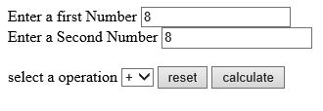

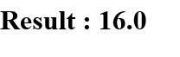

**Practical 1B**

**Aim**: Create a servlet for a login page. If the username and password are correct then it says message “Hello” else a message “login failed”.

**Program:**

***Index.html***

<!--

To change this template, choose Tools | Templates

and open the template in the editor.

-->

<!DOCTYPE html>

<html>

<head>

<title></title>

<meta http-equiv="Content-Type" content="text/html; charset=UTF-8">

</head>

<body>

<form action="ValidateServlet">

Enter username:

<input type="text" name="usr" ><br>

Enter password:

<input type="text" name="pass" ><br>

<input type="submit" value="submit">

</form>

</body>

</html>Top of Form

***ValidateServlet.java***

import java.io.IOException;

import java.io.PrintWriter;

import javax.servlet.ServletException;

import javax.servlet.annotation.WebServlet;

import javax.servlet.http.HttpServlet;

import javax.servlet.http.HttpServletRequest;

import javax.servlet.http.HttpServletResponse;

public class ValidateServlet extends HttpServlet {

protected void processRequest(HttpServletRequest request, HttpServletResponse response)

throws ServletException, IOException

{

response.setContentType("text/html;charset=UTF-8");

PrintWriter out = response.getWriter();

try {

out.println("<!DOCTYPE html>");

out.println("<html>");

out.println("<head>");

out.println("<title>Servlet ValidateServlet</title>");

out.println("</head>");

out.println("<body>");

String username = "abc";

String password = "123";

String usr1 = request.getParameter("usr");

String pass1 = request.getParameter("pass");

if((username.equals(usr1)) && (password.equals(pass1))) {

out.println("<h1> hello " + usr1 + “, Login success </h1>");

}

else {

out.println("<h1> Login unsuccessful </h1>");

}

out.println("</body>");

out.println("</html>");

} finally {

out.close();

}

}

**Output:**

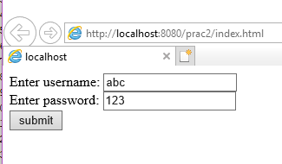

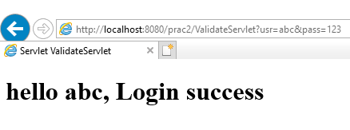

**Practical 1C**

**Aim**: Create a registration servlet in Java using JDBC. Accept the details such as Username, Password, Email, and Country from the user using HTML Form and store the registration details in the database.

**Program:**

***Index.html***

<!--

To change this template, choose Tools | Templates

and open the template in the editor.

-->

<!DOCTYPE html>

<html>

<head>

<title></title>

<meta http-equiv="Content-Type" content="text/html; charset=UTF-8">

</head>

<body>

<form action="RegistrationServlet">

Name:

<input type="text" name="usr" ><br>

Password:

<input type="text" name="pass" ><br>

Email:

<input type="text" name="email" ><br>

Country:

<input type="text" name="con" ><br>

<input type="submit" value="Submit"> &nbsp

<input type=“reset” value=”Clear”>

</form>

</body>

</html>

***RegistrationServlet.java***

import java.io.IOException;

import java.io.PrintWriter;

import javax.servlet.ServletException;

import javax.servlet.annotation.WebServlet;

import javax.servlet.http.HttpServlet;

import javax.servlet.http.HttpServletRequest;

import javax.servlet.http.HttpServletResponse;

import java.sql.*;

public class RegistrationServlet extends HttpServlet {

protected void processRequest(HttpServletRequest request, HttpServletResponse response)

throws ServletException, IOException

{

response.setContentType("text/html;charset=UTF-8");

PrintWriter out = response.getWriter();

try {

out.println("<!DOCTYPE html>");

out.println("<html>");

out.println("<head>");

out.println("<title>Servlet RegistrationServlet</title>");

out.println("</head>");

out.println("<body>");

String usr1 = request.getParameter("usr");

String pass1 = request.getParameter("pass");

String email1 = request.getParameter("email");

String con = request.getParameter("con");

try{

Class.forName("com.mysql.jdbc.Driver");

Connection con1 = DriverManager.getConnection("jdbc:mysql://localhost:3306/logindb","root","root");

PreparedStatement ptm = con1.prepareStatement("insert into tbluser value(?,?,?,?)");

ptm.setString(1, usr1);

ptm.setString(2, pass1);

ptm.setString(3, email1);

ptm.setString(4, con);

ptm.executeUpdate();

}catch(Exception se){

out.println("<h1> invalid details </h1>");

}

out.println("</body>");

out.println("</html>");

} finally {

out.close();

}

}

**Output :**

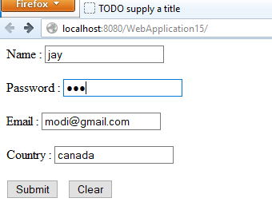

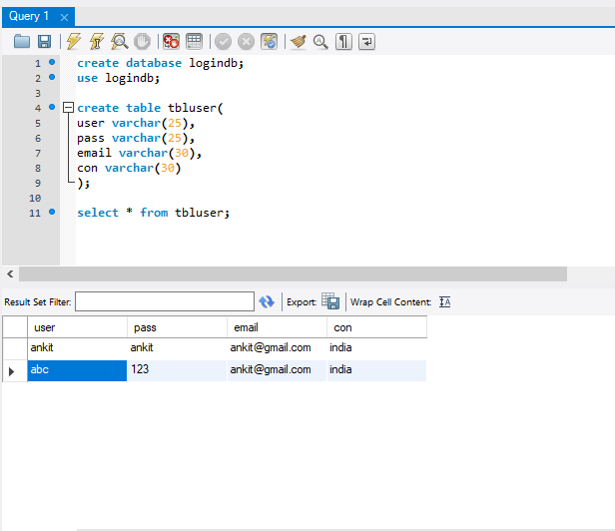

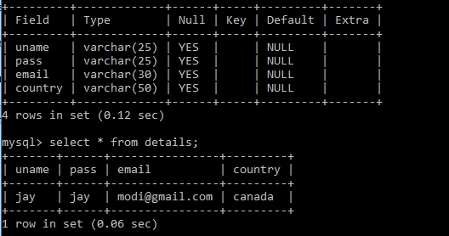

**Practical 2A**

**Aim**: Using Request Dispatcher Interface create a Servlet which will validate the password entered by the user, if the user has entered “Servlet” as password, then he will be forwarded to Welcome Servlet else the user will stay on the index.html page and an error message will be displayed.

**Program:**

***Index.html***

<html>

<head>

<title>TODO supply a title</title>

<meta charset="UTF-8">

<meta name="viewport" content="width=device-width, initial-scale=1.0">

</head>

<body>

<div>

<form action="LoginServlet">

Username <input type="text" name="uname"><br>

Password <input type="password" name="pass"><br>

<input type="submit" value="Submit"> &nbsp;

<input type="reset" value="Clear">

</form>

</div>

</body>

</html>

***LoginServlet.java***

package mypack;

import java.io.IOException;

import java.io.PrintWriter;

import javax.servlet.RequestDispatcher;

import javax.servlet.ServletException;

import javax.servlet.http.HttpServlet;

import javax.servlet.http.HttpServletRequest;

import javax.servlet.http.HttpServletResponse;

public class LoginServlet extends HttpServlet {

protected void processRequest(HttpServletRequest request, HttpServletResponse response) throws ServletException, IOException

{

response.setContentType("text/html;charset=UTF-8");

try( PrintWriter out = response.getWriter())

{

out.println("<!DOCTYPE html>");

out.println("<html>");

out.println("<head>");

out.println("<title>Servlet LoginServlet</title>");

out.println("</head>");

out.println("<body>");

String username = request.getParameter("uname");

String password = request.getParameter("pass");

if(username.equals("Admin")&&password.equals("Servlet"))

{

RequestDispatcher rd = request.getRequestDispatcher("WelcomeServlet");

rd.forward(request, response);

}

else

{

out.println("<h1>Invalid Login<h1>");

RequestDispatcher rd = request.getRequestDispatcher("index.html");

rd.include(request, response);

}

out.println("</body>");

out.println("</html>");

}

}

***WelcomeServlet.java***

package mypack;

import java.io.IOException;

import java.io.PrintWriter;

import javax.servlet.ServletException;

import javax.servlet.http.HttpServlet;

import javax.servlet.http.HttpServletRequest;

import javax.servlet.http.HttpServletResponse;

public class WelcomeServlet extends HttpServlet {

protected void processRequest(HttpServletRequest request, HttpServletResponse response) throws ServletException, IOException

{

response.setContentType("text/html;charset=UTF-8");

try (PrintWriter out = response.getWriter()) {

out.println("<!DOCTYPE html>");

out.println("<html>");

out.println("<head>");

out.println("<title>Servlet WelcomeServlet</title>");

out.println("</head>");

out.println("<body>");

String username = request.getParameter("uname");

out.println("<h1>Welcome "+username+"</h1>");

out.println("</body>");

out.println("</html>");

}

}

**Output:**

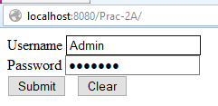

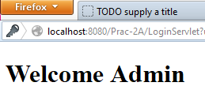

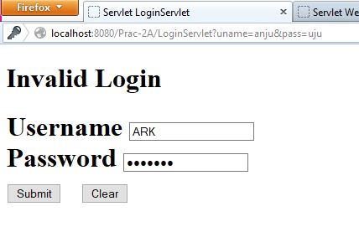

**Practical 2B**

**Aim**: Create a servlet that uses Cookies to store the number of times a user has visited servlet.

**Program code:-**

***Index.html***

<head>

<title>TODO supply a title</title>

<meta charset="UTF-8">

<meta name="viewport" content="width=device-width, initial-scale=1.0">

</head>

<body>

<h1 align="center">Cookies</h1>

<form action="cookiesServlet">

Enter your Name:<input type="text" name="name">

<input type="submit" value="cook">

<input type="reset">

</form></body>

***cookiesServlet.java***

package mypack;

import java.io.IOException;

import java.io.PrintWriter;

import javax.servlet.ServletException;

import javax.servlet.http.Cookie;

import javax.servlet.http.HttpServlet;

import javax.servlet.http.HttpServletRequest;

import javax.servlet.http.HttpServletResponse;

protected void processRequest(HttpServletRequest request, HttpServletResponse response)

throws ServletException, IOException

{

String name=request.getParameter("name");

response.setContentType("text/html;charset=UTF-8");

try (PrintWriter out = response.getWriter()) {

out.println("<!DOCTYPE html>");

out.println("<html><body>");

out.println("<h1>cookies Example</h1>");

out.println("<b>Welcome "+name+"</b>");

Cookie ck1=new Cookie("username",name);

Cookie ck2=new Cookie("visit","1");

response.addCookie(ck1);

response.addCookie(ck2);

out.println("<h1><a href=page2>Click to view next</a></h1>");

out.println("</body></html>");

}

}

***page2.java***

protected void processRequest(HttpServletRequest request, HttpServletResponse response)

throws ServletException, IOException {

Cookie[] ck=request.getCookies();

response.setContentType("text/html;charset=UTF-8");

try (PrintWriter out = response.getWriter()) {

out.println("<!DOCTYPE html>");

out.println("<html><body>");

for(int i=0;i<ck.length;i++){

if(ck[i].getName().equals("visit")) {

int count = Integer.parseInt(ck[i].getValue())+1;

out.println("<h1>Visit No: "+count+"</h1>");

ck[i]=new Cookie("visit",count+"");

response.addCookie(ck[i]); }

else

out.println(ck[i].getName()+" = "+ck[i].getValue());

} out.println("</body></html>");}}

**Output:**

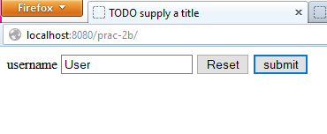

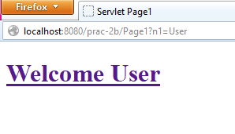

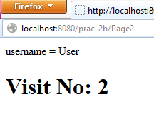

1. **Aim:** Create a servlet demonstrating the use of session creation and destruction. Also check whether the user has visited this page first time or has visited earlier also using sessions.

**Program Code:**

**index.html**

<html>

<head><title>Session Demo</title></head>

<form action="Page1" method="get" >

Enter User ID <input type="text" name="txtName"><br>

<input type="reset" ><input type="submit" >

</form>

</html>

**Page1.java**

package mypack;

import java.io.IOException;

import java.io.PrintWriter;

import javax.servlet.ServletException;

import javax.servlet.http.HttpServlet;

import javax.servlet.http.HttpServletRequest;

import javax.servlet.http.HttpServletResponse;

import javax.servlet.http.HttpSession;

public class Page1 extends HttpServlet {

public void doGet(HttpServletRequest request, HttpServletResponse response)

throws ServletException, IOException {

response.setContentType("text/html;charset=UTF-8");

PrintWriter out = response.getWriter();

out.println("<html><head><title>Servlet Page1</title></head>");

HttpSession hs = request.getSession(true);

if(hs.isNew()){

out.println("<body bgcolor=yellow>");

String name = request.getParameter("txtName");

hs.setAttribute("uname", name);

hs.setAttribute("visit", "1");

out.println("<h1>Welcome First Time</h1>");

}

else{

out.println("<h1>Welcome Again</h1>");

int visit = Integer.parseInt((String)hs.getAttribute("visit"))+1;

out.println("<h1>You Visited "+visit+"Times</h1>");

hs.setAttribute("visit", ""+visit);

}

out.println("<h1>Your Session ID "+hs.getId()+"</h1>");

out.println("<h1>You Logged in at "+new java.util.Date(hs.getCreationTime())+"</h1>");

out.println("<h1><a href=Page2>Click for Page 2 </a></h1>");

out.println("<h1><a href=Page3>Click for Page 3 </a></h1>");

out.println("<h1><a href=Page4>Click for Page 4 </a></h1>");

out.println("<h1><a href=LogoutServlet>Click to Terminate Session </a></h1>");

out.println("</body>");

out.println("</html>");

}

}

**Page2.java**

package mypack;

import java.io.IOException;

import java.io.PrintWriter;

import javax.servlet.ServletException;

import javax.servlet.http.HttpServlet;

import javax.servlet.http.HttpServletRequest;

import javax.servlet.http.HttpServletResponse;

import javax.servlet.http.HttpSession;

public class Page2 extends HttpServlet {

public void doGet(HttpServletRequest request, HttpServletResponse response)

throws ServletException, IOException {

response.setContentType("text/html;charset=UTF-8");

PrintWriter out = response.getWriter();

out.println("<html><head><title>Servlet Page2</title></head>");

HttpSession hs = request.getSession(false);

out.println("<h1>Welcome Again on Page No. 2</h1>");

int visit = Integer.parseInt((String)hs.getAttribute("visit"))+1;

out.println("<h1>You Visited "+visit+"Times</h1>");

hs.setAttribute("visit", ""+visit);

out.println("<h1>Your Session ID "+hs.getId()+"</h1>");

out.println("<h1>You Logged in at "+new java.util.Date(hs.getCreationTime())+"</h1>");

out.println("<h1><a href=Page1>Click for Page 1 </a></h1>");

out.println("<h1><a href=Page3>Click for Page 3 </a></h1>");

out.println("<h1><a href=Page4>Click for Page 4 </a></h1>");

out.println("<h1><a href=LogoutServlet>Click for Terminate Session </a></h1>");

out.println("</body>");

out.println("</html>");

}

}

**Page3.java**

package mypack;

import java.io.IOException;

import java.io.PrintWriter;

import javax.servlet.ServletException;

import javax.servlet.http.HttpServlet;

import javax.servlet.http.HttpServletRequest;

import javax.servlet.http.HttpServletResponse;

import javax.servlet.http.HttpSession;

public class Page3 extends HttpServlet {

public void doGet(HttpServletRequest request, HttpServletResponse response)

throws ServletException, IOException {

response.setContentType("text/html;charset=UTF-8");

PrintWriter out = response.getWriter();

out.println("<html><head><title>Servlet Page3</title></head>");

HttpSession hs = request.getSession(false);

out.println("<h1>Welcome Again on Page 3</h1>");

int visit = Integer.parseInt((String)hs.getAttribute("visit"))+1;

out.println("<h1>You Visited "+visit+"Times</h1>");

hs.setAttribute("visit", ""+visit);

out.println("<h1>Your Session ID "+hs.getId()+"</h1>");

out.println("<h1>You Logged in at "+new java.util.Date(hs.getCreationTime())+"</h1>");

out.println("<h1><a href=Page1>Click for Page 1 </a></h1>");

out.println("<h1><a href=Page2>Click for Page 2 </a></h1>");

out.println("<h1><a href=Page4>Click for Page 4 </a></h1>");

out.println("<h1><a href=LogoutServlet>Click for Terminate Session </a></h1>");

out.println("</body>");

out.println("</html>");

}

}

**Page4.java**

package mypack;

import java.io.IOException;

import java.io.PrintWriter;

import javax.servlet.ServletException;

import javax.servlet.http.HttpServlet;

import javax.servlet.http.HttpServletRequest;

import javax.servlet.http.HttpServletResponse;

import javax.servlet.http.HttpSession;

public class Page4 extends HttpServlet {

public void doGet(HttpServletRequest request, HttpServletResponse response)

throws ServletException, IOException {

response.setContentType("text/html;charset=UTF-8");

PrintWriter out = response.getWriter();

out.println("<html><head><title>Servlet Page2</title></head>");

HttpSession hs = request.getSession(false);

out.println("<h1>Welcome Again on Page No. 4</h1>");

int visit = Integer.parseInt((String)hs.getAttribute("visit"))+1;

out.println("<h1>You Visited "+visit+"Times</h1>");

hs.setAttribute("visit", ""+visit);

out.println("<h1>Your Session ID "+hs.getId()+"</h1>");

out.println("<h1>You Logged in at "+new java.util.Date(hs.getCreationTime())+"</h1>");

out.println("<h1><a href=Page1>Click for Page 1 </a></h1>");

out.println("<h1><a href=Page2>Click for Page 2 </a></h1>");

out.println("<h1><a href=Page3>Click for Page 3 </a></h1>");

out.println("<h1><a href=LogoutServlet>Click for Terminate Session </a></h1>");

out.println("</body>");

out.println("</html>");

}

}

**LogoutServlet.java**

package mypack;

import java.io.IOException;

import java.io.PrintWriter;

import javax.servlet.ServletException;

import javax.servlet.http.HttpServlet;

import javax.servlet.http.HttpServletRequest;

import javax.servlet.http.HttpServletResponse;

public class LogoutServlet extends HttpServlet {

public void doGet(HttpServletRequest request, HttpServletResponse response)

throws ServletException, IOException {

response.setContentType("text/html;charset=UTF-8");

PrintWriter out = response.getWriter();

out.println("<html>");

out.println("<head>");

out.println("<title>Servlet LogoutServlet</title>");

out.println("</head>");

out.println("<body>");

javax.servlet.http.HttpSession hs = request.getSession();

if(hs != null) hs.invalidate();

out.println("<h1>You are Logged out now........</h1>");

out.println("</body>");

out.println("</html>");

}

}

**Output:**

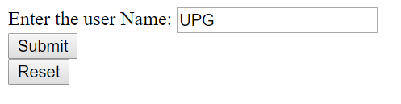

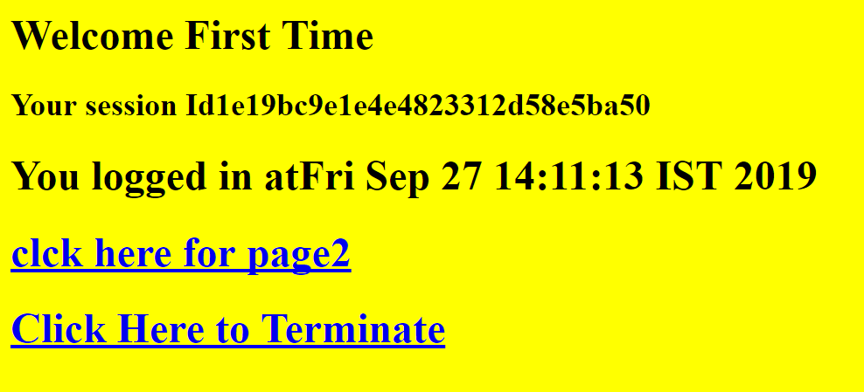

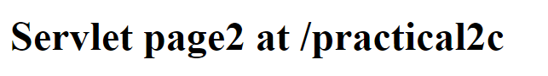

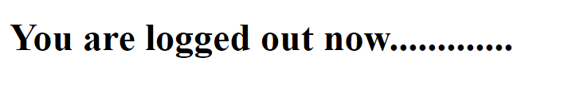

**Practical-3**

1. **Aim:** Create a servlet application to upload and download a file.

**Program Code:**

**index.html**

<!DOCTYPE html>

<!--

To change this license header, choose License Headers in Project Properties.

To change this template file, choose Tools | Templates

and open the template in the editor.

-->

<html>

<body>

<form action="FileUploadServlet" method="post" enctype="multipart/form-data">

Select File to Upload:<input type="file" name="file" id="file"><br>

<br>

Destination <input type="text" value="/tmp" name="destination">

<br>

<br>

<input type="submit" value="Upload file" name="upload" id="upload">

</form>

<br><br>

<h1>File Download Application</h1>

Click <a href="FileDownloadServlet?filename=Cyber.txt">Cyber</a>

<br/><br/>

Click <a href="FileDownloadServlet?filename=CyberSecurity.txt">Cyber Security</a>

</body> </html>

**FileDownloadServlet.java**

package mypack;

import java.io.IOException;

import java.io.InputStream;

import java.io.PrintWriter;

import javax.servlet.ServletContext;

import javax.servlet.ServletException;

import javax.servlet.ServletOutputStream;

import javax.servlet.annotation.WebServlet;

import javax.servlet.http.HttpServlet;

import javax.servlet.http.HttpServletRequest;

import javax.servlet.http.HttpServletResponse;

@WebServlet(name = "FileDownloadServlet", urlPatterns={"/FileDownloadServlet"})

public class FileDownloadServlet extends HttpServlet {

protected void processRequest(HttpServletRequest request, HttpServletResponse response)

throws ServletException, IOException {

response.setContentType("text/html;charset=UTF-8");

String fileToDownload = request.getParameter("filename");

System.err.println("Downloading file now...");

downloadFile(request,response,fileToDownload);

}

private void downloadFile(HttpServletRequest request, HttpServletResponse response, String fileName ) throws ServletException, IOException{

int length = 0;

try(ServletOutputStream outputStream = response.getOutputStream()){

ServletContext context = getServletConfig().getServletContext();

response.setContentType((context.getMimeType(fileName) !=null) ?

context.getMimeType(fileName) : "application/pdf");

response.setHeader("Content-Disposition", "attachment; filename=\""+

fileName);

InputStream inputStream = context.getResourceAsStream("/"+

fileName);

byte[] bytes = new byte[1024];

while((inputStream !=null) && ((length = inputStream.read(bytes)) != -1)){

outputStream.write(bytes,0,length);

}

outputStream.flush();

}

}

**FileUploadServlet.java**

package myPack;

import java.io.File;

import java.io.FileNotFoundException;

import java.io.FileOutputStream;

import java.io.IOException;

import java.io.InputStream;

import java.io.OutputStream;

import java.io.PrintWriter;

import javax.servlet.ServletException;

import javax.servlet.annotation.MultipartConfig;

import javax.servlet.http.HttpServlet;

import javax.servlet.http.HttpServletRequest;

import javax.servlet.http.HttpServletResponse;

import javax.servlet.http.Part;

@MultipartConfig

public class FileUploadServlet extends HttpServlet {

protected void processRequest(HttpServletRequest req, HttpServletResponse res)

throws ServletException, IOException {

res.setContentType("text/html;charset=UTF-8");

PrintWriter out = res.getWriter();

String path = req.getParameter("destination");

Part filePart = req.getPart("file");

String filename = filePart.getSubmittedFileName().toString();

out.print("<br><br><hr> file name: "+filename);

OutputStream os = null;

InputStream is = null;

try {

os = new FileOutputStream(new File(path+File.separator+filename));

is = filePart.getInputStream();

int read=0;

while ((read = is.read()) != -1) {

os.write(read);

}

out.println("<br>file uploaded sucessfully...!!!");

}

catch(FileNotFoundException e){out.print(e);}

}

}

**Output:**

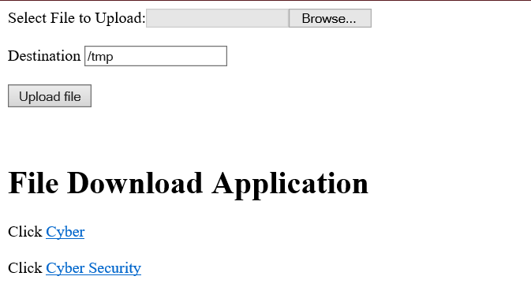

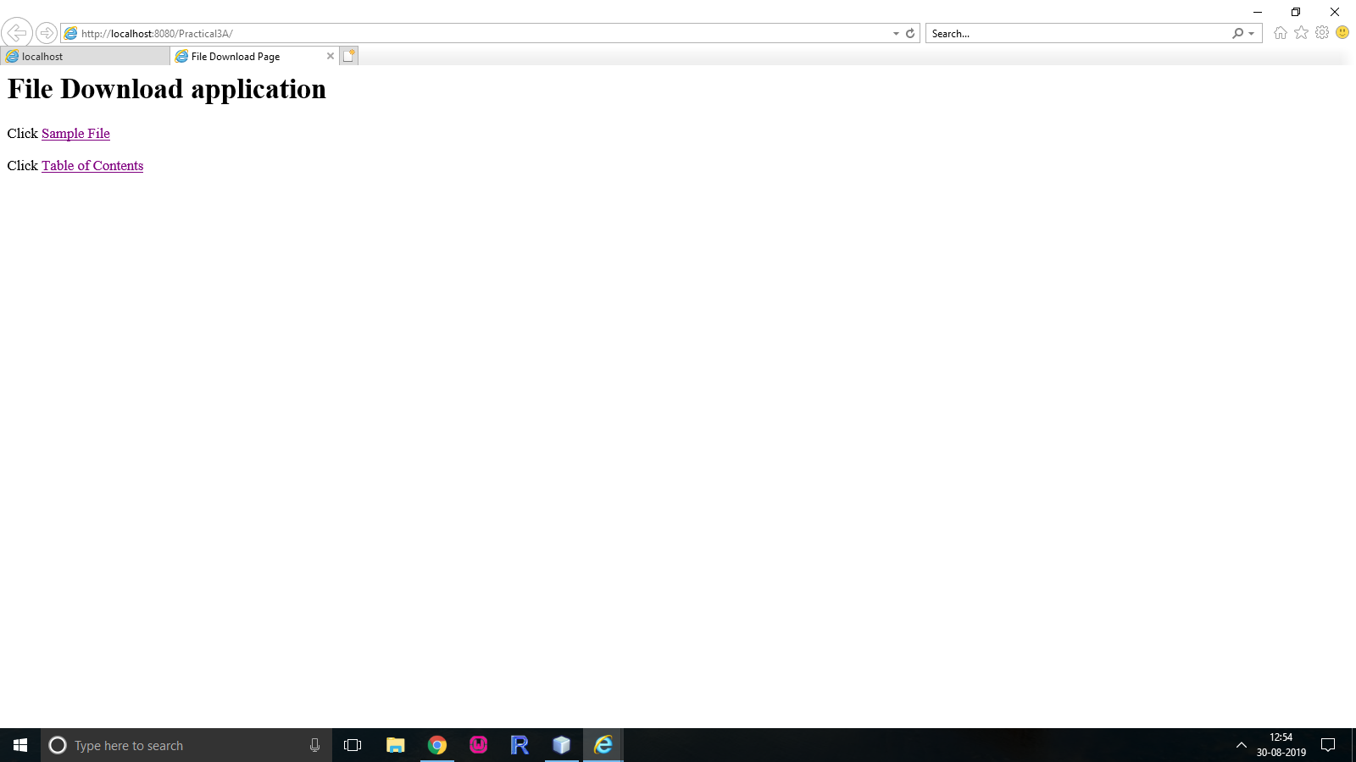

1. **Aim:** Develop Simple Servlet Question Answer Application using Database.

**Program Code:**

**index.html**

<html> <head><title>Quiz Application</title></head>

<body>

<h1>Welcome to Quiz Servlet </h1>

<h1><a href="QuizServlet" >CLICK TO START QUIZ</a></h1>

</body>

</html>

**QuizServlet.java**

package mypack;

import java.io.*;

import java.sql.*;

import javax.servlet.*;

import javax.servlet.http.*;

public class QuizServlet extends HttpServlet {

public void doGet(HttpServletRequest request, HttpServletResponse response)

throws ServletException, IOException {

response.setContentType("text/html;charset=UTF-8");

PrintWriter out = response.getWriter();

out.println("<form action=ShowResult >");

try {

Class.forName("com.mysql.jdbc.Driver");

Connection con = DriverManager.getConnection("jdbc:mysql://localhost:3306/qadb","root","root");

Statement stmt = con.createStatement();

ResultSet res = stmt.executeQuery("select * from quiz");

out.println("<table border=1 >");

int qno=0;

while(res.next()){

qno++;

out.println("<tr><td>"+res.getString(1)+"</td>");

out.println("<td>"+res.getString(2)+"</td></tr>");

out.println("<tr><td><input type=radio name="+qno+" value="+res.getString(3)+"></td><td>"+res.getString(3)+"</td></tr>");

out.println("<tr><td><input type=radio name="+qno+" value="+res.getString(4)+"></td><td>"+res.getString(4)+"</td></tr>");

out.println("<tr><td><input type=radio name="+qno+" value="+res.getString(5)+"></td><td>"+res.getString(5)+"</td></tr>");

out.println("<tr><td><input type=radio name="+qno+" value="+res.getString(6)+"></td><td>"+res.getString(6)+"</td></tr>");

}

}catch(Exception e){out.println(e);}

out.println("</table>");

out.println("<input type=reset >");

out.println("<input type=submit value=SUBMIT >");

out.println("</form>");

}

}

**ShowResult.java**

package mypack;

import java.io.*;

import java.sql.*;

import javax.servlet.*;

import javax.servlet.http.*;

public class ShowResult extends HttpServlet {

public void doGet(HttpServletRequest request, HttpServletResponse response)

throws ServletException, IOException {

response.setContentType("text/html;charset=UTF-8");

PrintWriter out = response.getWriter();

try {

Class.forName("com.mysql.jdbc.Driver");

Connection con = DriverManager.getConnection("jdbc:mysql://localhost:3306/qadb","root","root");

Statement stmt = con.createStatement();

ResultSet res = stmt.executeQuery("select ans from quiz");

int count =0, qno=0;

while(res.next()){

if(res.getString(1).equals(request.getParameter(""+(++qno))))

{ count++;

out.println("<h1>Correct </h1>");

}

else {

out.println("<h1>Incorrect </h1>");

}

}

out.println("<h1>Your Score is "+count+" </h1>");

}catch(Exception e){out.println(e);}

} }

**Output:**

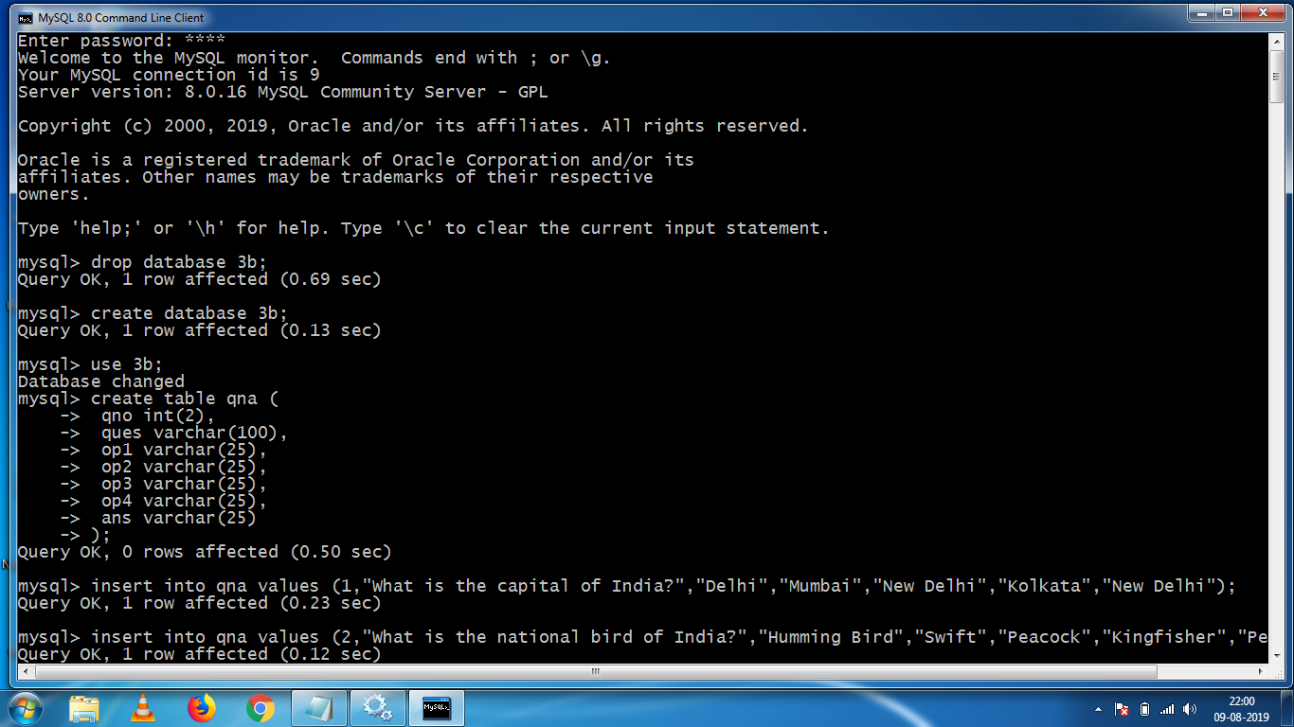

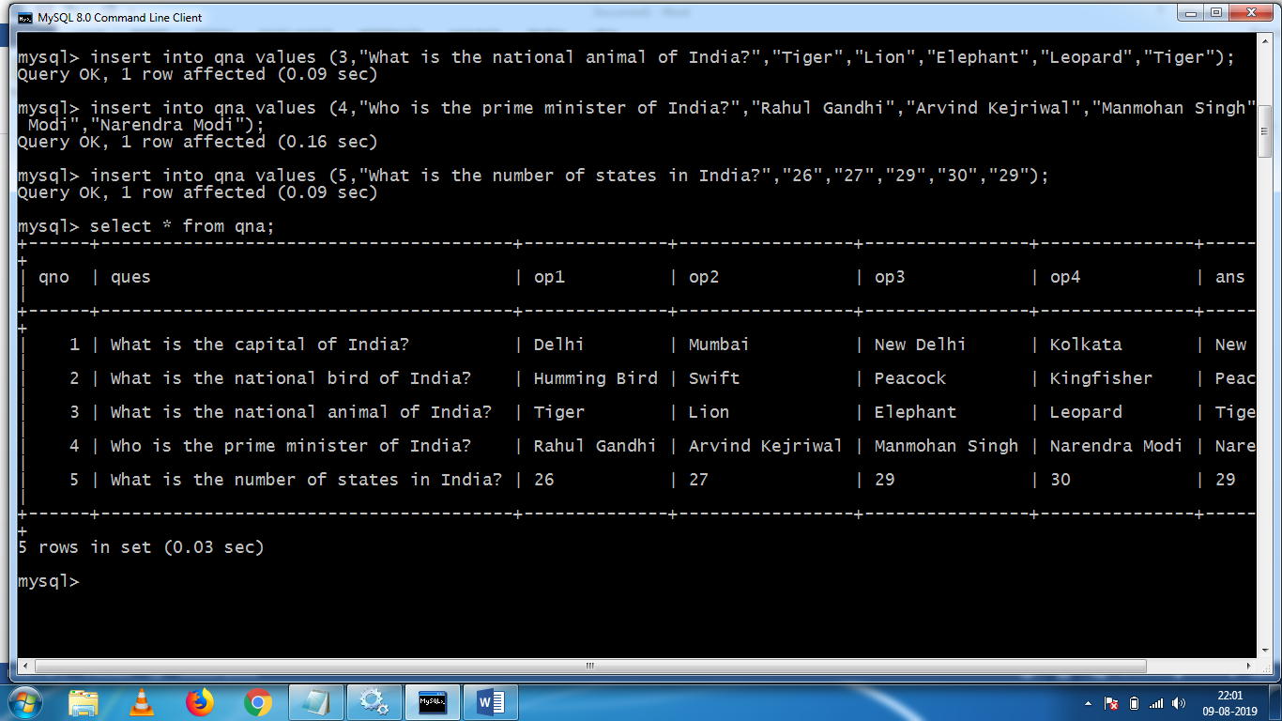

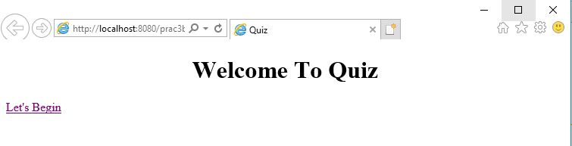

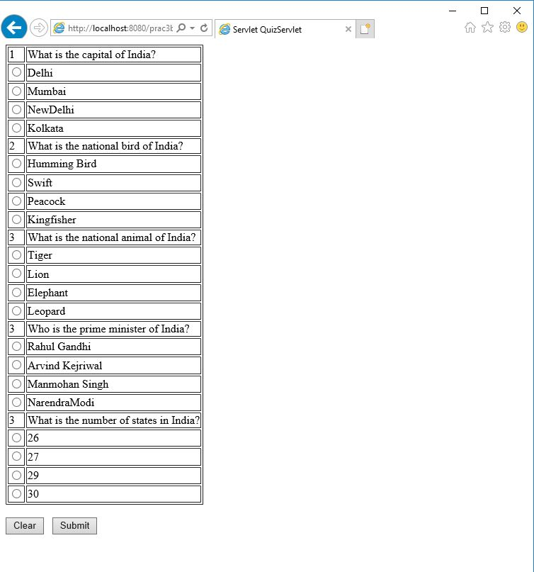

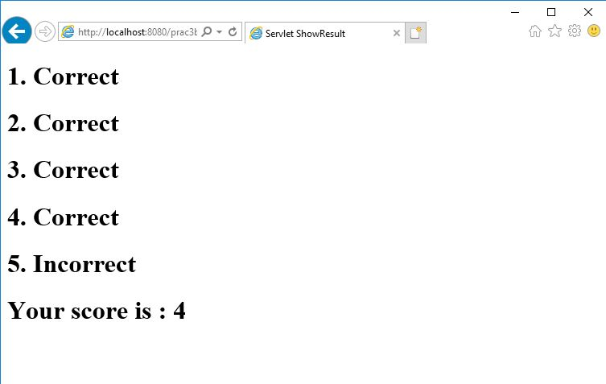

1. **Aim:** Create simple Servlet application to demonstrate Non-Blocking Read Operation.

**Program Code:**

**index.html**

<html>

<head>

<title>Non Blocking IO</title>

<meta charset="UTF-8">

<meta http-equiv="Refresh" content="0; URL=NonBlockingServlet">

</head>

<body>

</body>

</html>

**NonBlockingServlet.java**

package nonblkapp;

import java.io.*;

import java.net.*;

import javax.servlet.*;

import javax.servlet.http.*;

public class NonBlockingServlet extends HttpServlet {

protected void service(HttpServletRequest request, HttpServletResponse response)

throws ServletException, IOException {

response.setContentType("text/html;charset=UTF-8");

try (PrintWriter out = response.getWriter()) {

/* TODO output your page here. You may use following sample code. */

out.println("<h1>FileReader</h1>");

String filename="/booklist.txt";

ServletContext c=getServletContext();

InputStream in=c.getResourceAsStream(filename);

String path="http://"+request.getServerName()+":"+request.getServerPort()+request.getContextPath()+"/ReadingNonBloclingServlet";

URL url=new URL(path);

HttpURLConnection conn=(HttpURLConnection)url.openConnection();

conn.setChunkedStreamingMode(2); //number of bytes to write in each chunk.

conn.setDoOutput(true);

conn.connect();

if(in!=null)

{

InputStreamReader inr=new InputStreamReader(in);

BufferedReader br = new BufferedReader(inr);

String text="";

System.out.println("Reading started....");

BufferedWriter bw=new BufferedWriter(new OutputStreamWriter(conn.getOutputStream()));

while((text=br.readLine())!=null){

out.print("<hr>"+text);

try{

Thread.sleep(1000);

out.flush();

}catch(Exception ex){ out.println(ex); }

}out.print("reading completed....");

bw.flush();

bw.close();

}

}

}

}

**ReadingListener.java**

package nonblkapp;

import java.io.IOException;

import java.util.logging.Level;

import java.util.logging.Logger;

import javax.servlet.AsyncContext;

import javax.servlet.ReadListener;

import javax.servlet.ServletInputStream;

public class ReadingListener implements ReadListener

{

private ServletInputStream input = null;

private AsyncContext ac = null;

ReadingListener(ServletInputStream in, AsyncContext c) {

input = in;

ac = c;

}

@Override

public void onDataAvailable() throws IOException {

}

public void onAllDataRead() throws IOException {

ac.complete();

}

public void onError(final Throwable t) {

ac.complete();

t.printStackTrace();

}

}

**ReadingNonBlocingServlet.java**

package nonblkapp;

import java.io.IOException;

import java.io.PrintWriter;

import javax.servlet.AsyncContext;

import javax.servlet.ServletException;

import javax.servlet.ServletInputStream;

import javax.servlet.annotation.WebServlet;

import javax.servlet.http.HttpServlet;

import javax.servlet.http.HttpServletRequest;

import javax.servlet.http.HttpServletResponse;

/**

*

* @author Beena Kapadia

*/

@WebServlet (name = "ReadingNonBlockingServlet", urlPatterns = {"/ReadingNonBlockingServlet"},asyncSupported = true )

public class ReadingNonBlockingServlet extends HttpServlet {

@Override

protected void service(HttpServletRequest request, HttpServletResponse response)

throws ServletException, IOException {

response.setContentType("text/html");

AsyncContext ac = request.startAsync();

ServletInputStream in=request.getInputStream();

in.setReadListener(new ReadingListener(in,ac));

}

}

**Output:**

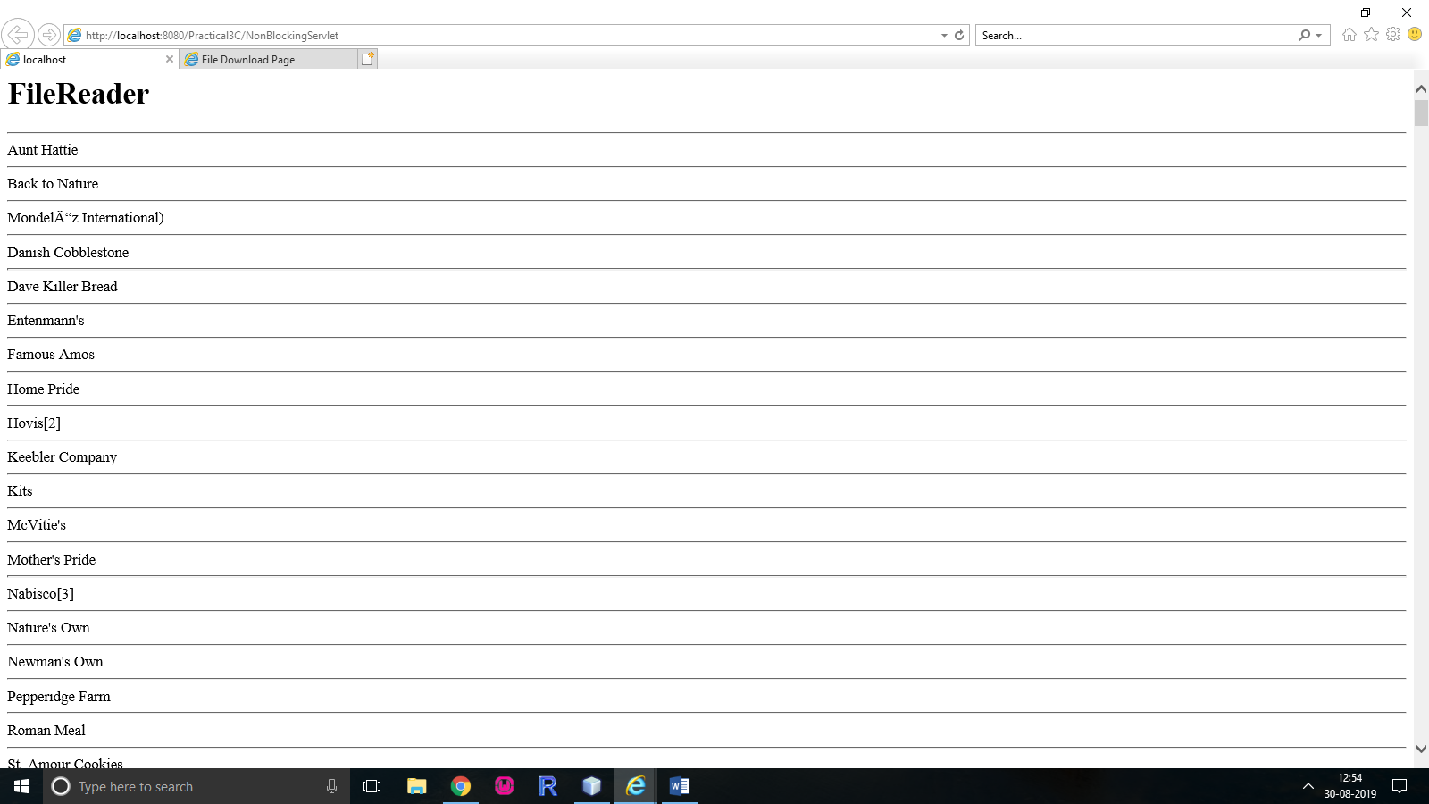

**Practical-4**

1. **Aim:** Develop a simple JSP application to display values obtained from the use of intrinsic objects of various types.

**Program Code:**

**index.html**

<!DOCTYPE html>

<!--

To change this license header, choose License Headers in Project Properties.

To change this template file, choose Tools | Templates

and open the template in the editor.

-->

<html>

<head>

<title>TODO supply a title</title>

<meta charset="UTF-8">

<meta name="viewport" content="width=device-width, initial-scale=1.0">

</head>

<body>

<div>TODO write content</div>

<a href="Prac_4A.jsp">Click Here</a>

</body>

</html>

**Prac_4A.jsp**

<%@page contentType="text/html" pageEncoding="UTF-8"%>

<html><head><title>JSP Page</title></head>

<body>

<h1>Use of Intrinsic Objects in JSP</h1>

<h1>Request Object </h1>

Query String <%=request.getQueryString() %><br>

Context Path <%=request.getContextPath() %><br>

Remote Host <%=request.getRemoteHost() %><br>

<h1>Response Object </h1>

Character Encoding Type <%=response.getCharacterEncoding() %><br>

Content Type <%=response.getContentType() %><br>

Locale <%=response.getLocale() %><br>

<h1>Session Object </h1>

ID <%=session.getId() %><br>

Creation Time <%=new java.util.Date(session.getCreationTime()) %><br>

Last Access Time<%=new java.util.Date(session.getLastAccessedTime()) %><br>

</body>

</html>

**Output:**

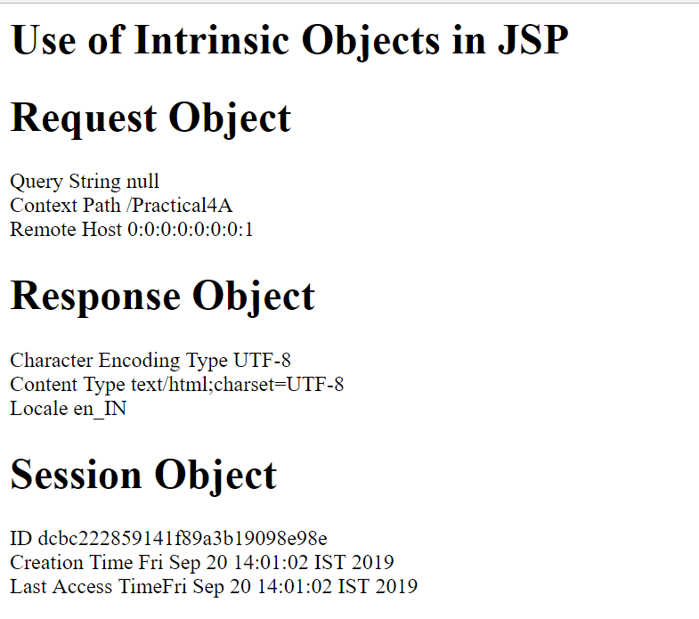

1. **Aim:** Develop a simple JSP application to pass values from one page to another with validations. (Name-txt, age-txt, hobbies-checkbox, email-txt,gender-radio button).

**Program Code:**

**index.html**

<html><head><title>User Information Paage</title>

</head>

<body>

<form action="Validate.jsp">

Enter Your Name<input type="text" name="name" ><br>

Enter Your Age<input type="text" name="age" ><br>

Select Hobbies

<input type="checkbox" name="hob" value="Singing">Singing

<input type="checkbox" name="hob" value="Reading">Reading Books

<input type="checkbox" name="hob" value="Football">Playing Football<br>

Enter E-mail<input type="text" name="email" ><br>

Select Gender

<input type="radio" name="gender" value="male">Male

<input type="radio" name="gender" value="female">Female

<input type="radio" name="gender" value="other">Other<br>

<input type="hidden" name="error" value="">

<input type="submit" value="Submit Form">

<br>

</form>

</body>

</html>

**Validate.jsp**

<%@page contentType="text/html" pageEncoding="UTF-8" import="mypack.*" %>

<html><head><title>JSP Page</title></head>

<body>

<h1>Validation Page</h1>

<jsp:useBean id="obj" scope="request"

class="mypack.CheckerBean" >

<jsp:setProperty name="obj" property="*"/>

</jsp:useBean>

<%

if (obj.validate())

{

%>

<jsp:forward page="successful.jsp"/>

<% }

else {

%>

<jsp:include page="index.html"/>

<%}%>

<%=obj.getError() %>

</body>

</html>

**CheckerBean.java**

package mypack;

public class CheckerBean {

private String name, age, hob, email, gender,error;

public CheckerBean(){error="";}

public void setName(String n){name=n;}

public void setAge(String a){age=a;}

public void setHob(String h){hob=h;}

public void setEmail(String e){email=e;}

public void setGender(String g){gender=g;}

public void setError(String e){error=e;}

public String getName(){return name;}

public String getAge(){return age;}

public String getHob(){return hob;}

public String getEmail(){return email;}

public String getGender(){return gender;}

public String getError(){return error;}

public boolean validate(){

boolean res=true;

if(name.trim().equals("")) {error+="<br>Enter First Name";res=false;}

if(age.length() > 2 )

{error+="<br>Age Invalid";res=false;}

return res;

}

}

**successful.jsp**

<html>

<head>

<meta http-equiv="Content-Type" content="text/html; charset=UTF-8">

<title>JSP Page</title>

</head>

<body>

<h1>DATA VALIDATED SUCCESSFULLY </h1>

</body>

</html>

**Output:**

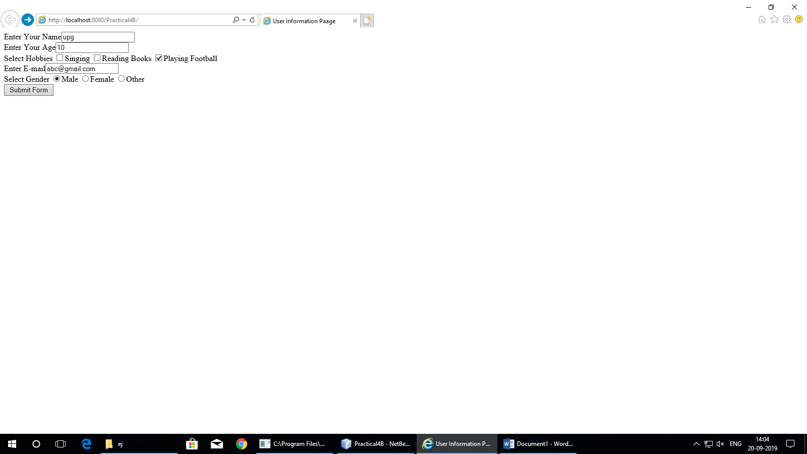

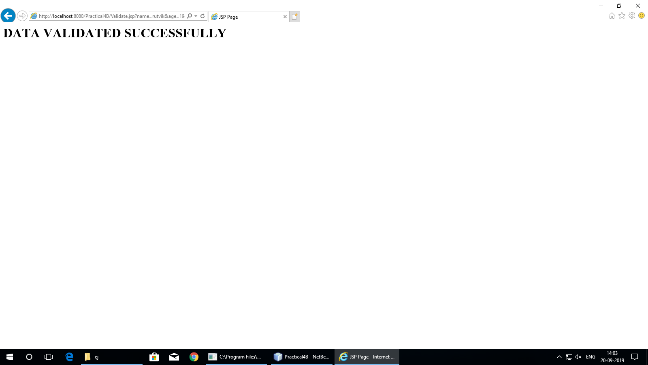

1. **Aim:** Create a registration and login JSP application to register and authenticate the user based on username and password using JDBC.

**Program Code:**

**index.html**

<html>

<head><title>JSP With JDBC</title></head>

<body>

<h1><a href="Register.html" >New User Register Here</a></h1>

<h1><a href="Login.html" >Click Here to Login</a></h1>

</body>

</html>

**Regsiter.html**

<html><head><title>New User Registration Page</title></head>

<body>

<form action="Register.jsp" >

<h1> New User Registration Page</h1>

Enter User Name <input type="text" name="txtName" ><br>

Enter Password <input type="password" name="txtPass1" ><br>

Re-Enter Password<input type="password" name="txtPass2" ><br>

Enter Email<input type="text" name="txtEmail" ><br>

Enter Country Name <input type="text" name="txtCon" ><br>

<input type="reset" ><input type="submit" value="REGISTER" >

</form>

</body>

</html>

**Register.jsp**

<%@page contentType="text/html" import="java.sql.*"%>

<html><body>

<h1>Registration JSP Page</h1>

<%

String uname=request.getParameter("txtName");

String pass1 = request.getParameter("txtPass1");

String pass2 = request.getParameter("txtPass2");

String email = request.getParameter("txtEmail");

String ctry = request.getParameter("txtCon");

if(pass1.equals(pass2)){

try{

Class.forName("com.mysql.jdbc.Driver");

Connection con = DriverManager.getConnection("jdbc:mysql://localhost:3306/4c");

PreparedStatement stmt = con.prepareStatement("insert into user values (?,?,?,?)");

stmt.setString(1, uname); stmt.setString(2, pass1);

stmt.setString(3, email); stmt.setString(4, ctry);

int row = stmt.executeUpdate();

if(row==1) { out.println("Registration Successful"); }

else {

out.println("Registration FFFFFAAAIIILLLL !!!!");

%>

<jsp:include page="Register.html" ></jsp:include>

<%

}

}catch(Exception e){out.println(e);}

}

else

{

out.println("<h1>Password Mismatch</h1>");

%>

<jsp:include page="Register.html" ></jsp:include>

<% }

%>

</body>

</html>

**Login.html**

<html>

<body>

<h1>Login Page</h1>

<form action="Login.jsp" >

Enter User Name <input type="text" name="txtName" ><br>

Enter Password <input type="password" name="txtPass" ><br>

<input type="reset" ><input type="submit" value="~~~LOGIN~~" >

</form>

</body>

</html>

**Login.jsp**

<%@page contentType="text/html" import="java.sql.*"%>

<html><body>

<h1>Registration JSP Page</h1>

<%

String uname=request.getParameter("txtName");

String pass = request.getParameter("txtPass");

try{

Class.forName("com.mysql.jdbc.Driver");

Connection con = DriverManager.getConnection("jdbc:mysql://localhost:3306/4c");

PreparedStatement stmt = con.prepareStatement("select password from user where username=?");

stmt.setString(1, uname);

ResultSet rs = stmt.executeQuery();

if(rs.next()){

if(pass.equals(rs.getString(1)))

{

out.println("<h1>~~~ LOGIN SUCCESSFULLL ~~~ </h1>");

}

}

else{

out.println("<h1>User Name not exist !!!!!</h1>");

%>

<jsp:include page="Register.html" ></jsp:include>

<%

}

}catch(Exception e){out.println(e);}

%>

</body>

</html>

**Output:**

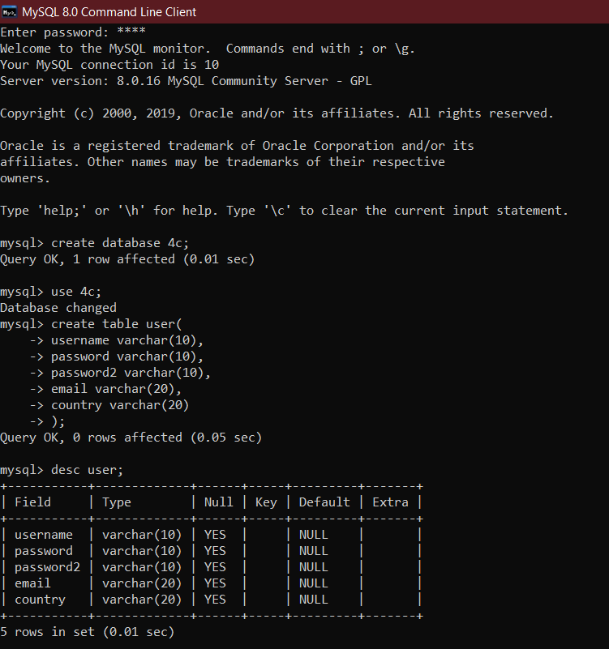

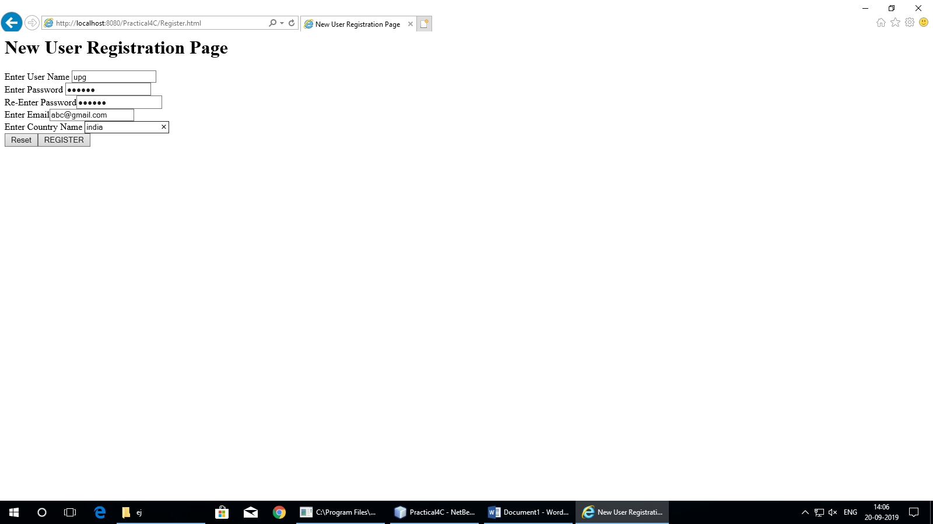

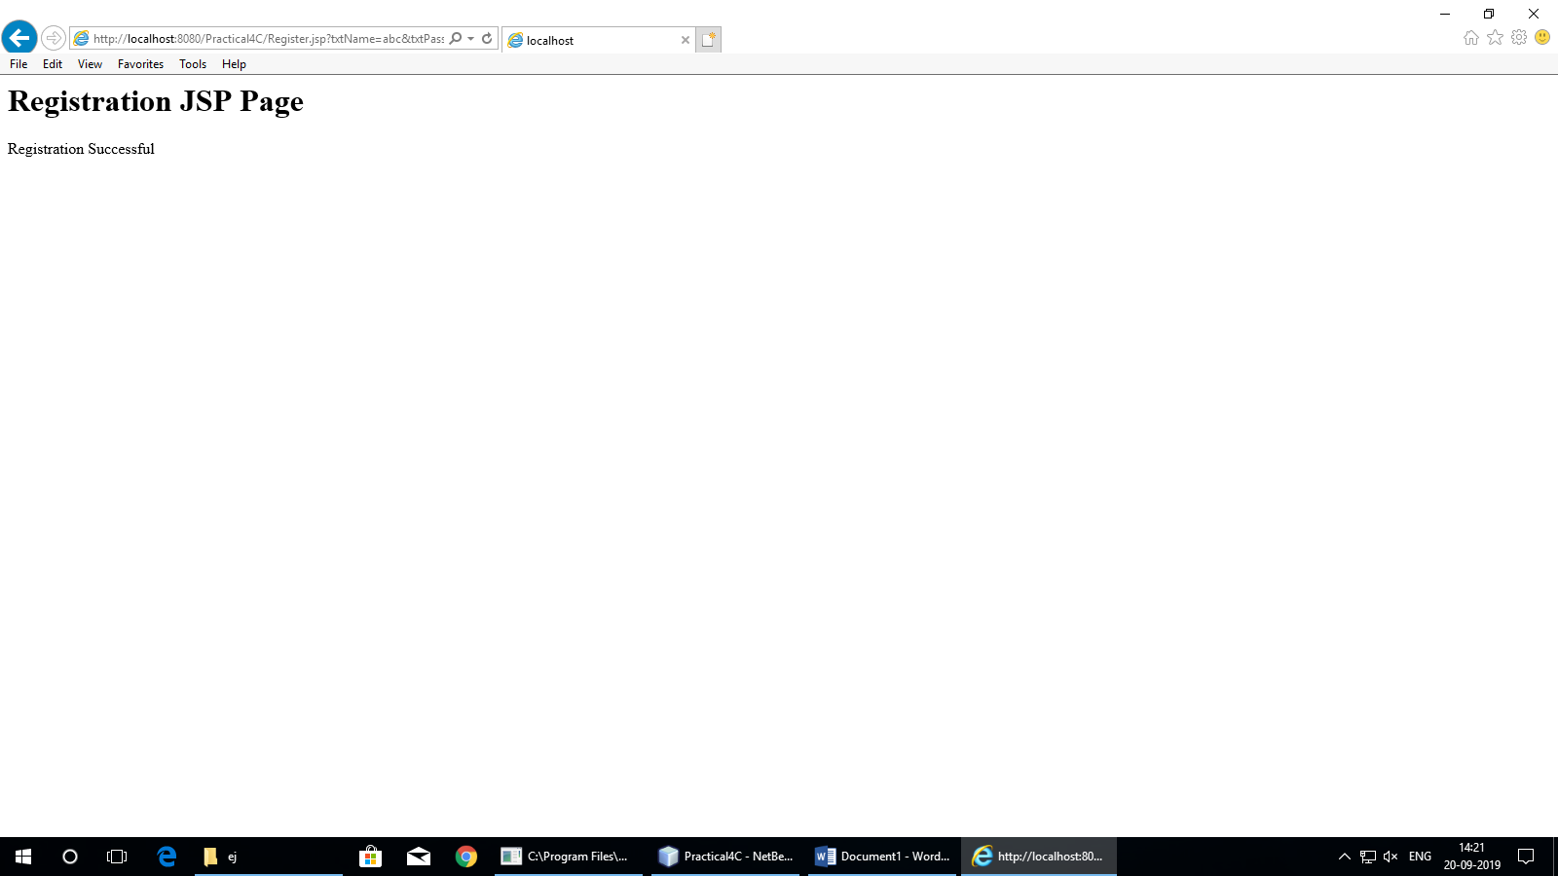

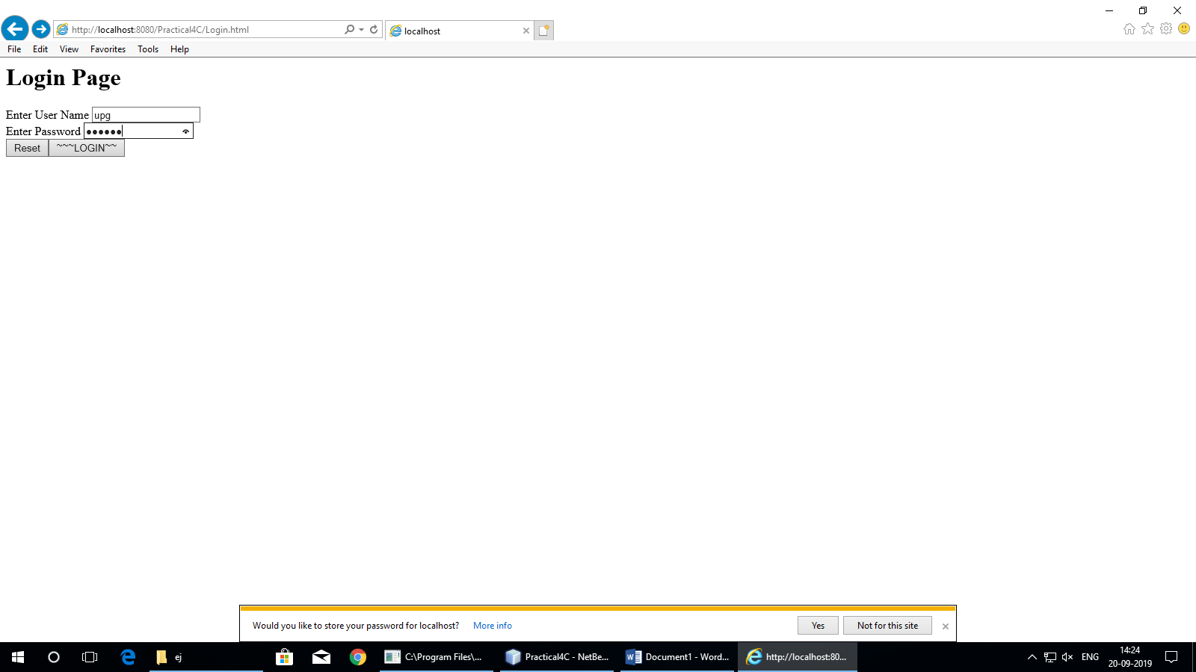

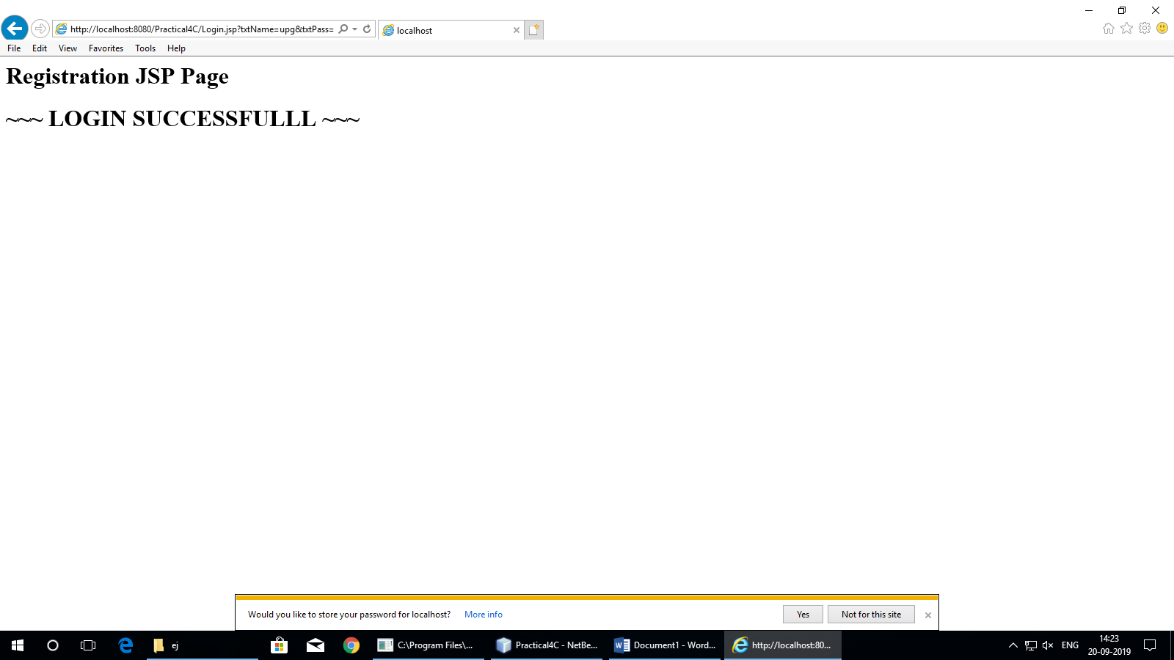

**Practical-5**

1. **Aim:** Create an html page with fields, eno, name, age, desg, salary. Now on submit this data to a JSP page which will update the employee table of database with matching eno.

**Program Code:**

**index.html**

<html>

<body>

<form action="UpdateEmp.jsp" >

Enter Employee Number<input type="text" name="txtEno" ><br>

Enter Name<input type="text" name="txtName" ><br>

Enter age<input type="text" name="txtAge" ><br>

Enter Salary<input type="text" name="txtSal" ><br>

<input type="reset" ><input type="submit">

</form>

</body>

</html>

**UpdateEmp.jsp**

<%@page contentType="text/html" import="java.sql.*" %>

<html>

<body>

<h1>Employee Record Update</h1>

<%

String eno=request.getParameter("txtEno");

String name=request.getParameter("txtName");

String age = request.getParameter("txtAge");

String sal = request.getParameter("txtSal");

try{

Class.forName("com.mysql.jdbc.Driver");

Connection con = DriverManager.getConnection("jdbc:mysql://localhost:3306/empdb");

PreparedStatement stmt = con.prepareStatement("select * from emp where empid=?");

stmt.setString(1, eno);

ResultSet rs = stmt.executeQuery();

if(rs.next()){

out.println("<h1>~~~ Employee "+name+" Exist ~~~ </h1>");

PreparedStatement pst1= con.prepareStatement("update emp set salary=? where empid=?");

PreparedStatement pst2= con.prepareStatement("update emp set age=? where empid=?");

pst1.setString(1, sal); pst1.setString(2, eno);

pst2.setString(1, age); pst2.setString(2, eno);

pst1.executeUpdate(); pst2.executeUpdate();

}

else{

out.println("<h1>Employee Record not exist !!!!!</h1>");

}

}catch(Exception e){out.println(e);}

%>

</body>

</html>

**Output:**

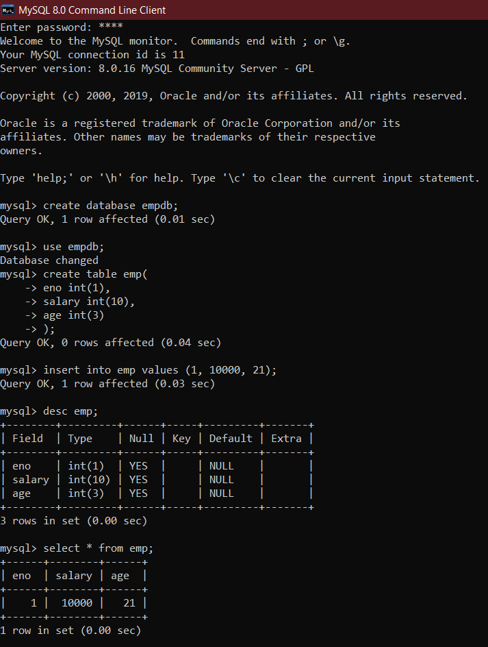

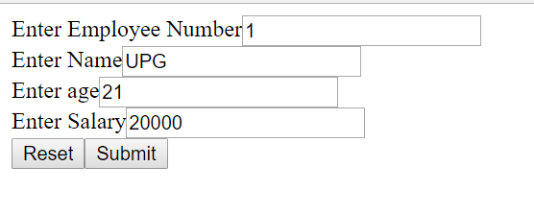

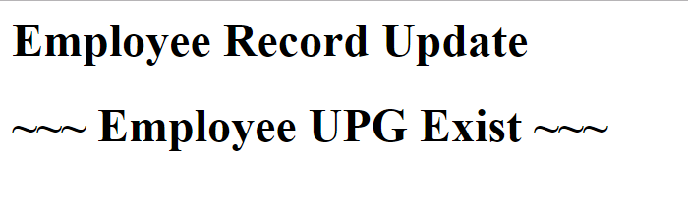

1. **Aim:** Create a JSP page to demonstrate the use of Expression language.

**Program Code:**

**index.html**

<!DOCTYPE html>

<!--

To change this license header, choose License Headers in Project Properties.

To change this template file, choose Tools | Templates

and open the template in the editor.

-->

<html>

<head>

<title>TODO supply a title</title>

<meta charset="UTF-8">

<meta name="viewport" content="width=device-width, initial-scale=1.0">

</head>

<body>

<div>TODO write content</div>

<a href="Bill.jsp">Click Here</a>

</body>

</html>

**Bill.jsp**

<%@page contentType="text/html" pageEncoding="UTF-8"%>

<html><head><title>JSP Page</title></head>

<body>

<h1>Expression Language Demo</h1>

<%! java.util.Date dt = new java.util.Date(); %>

<%! int val1 = 10, val2=20, result =0; %>

<% application.setAttribute("val1",10); %>

<% application.setAttribute("val2",20); %>

<% application.setAttribute("result",0); %>

<% application.setAttribute("dt",new java.util.Date()); %>

<h1>First Number is ${val1}</h1>

<h1>Second Number is ${val2}</h1>

<h1>Sum is ${val1+val2}</h1>

<h1>Today is ${dt}</h1>

</body>

</html>

**Output:**

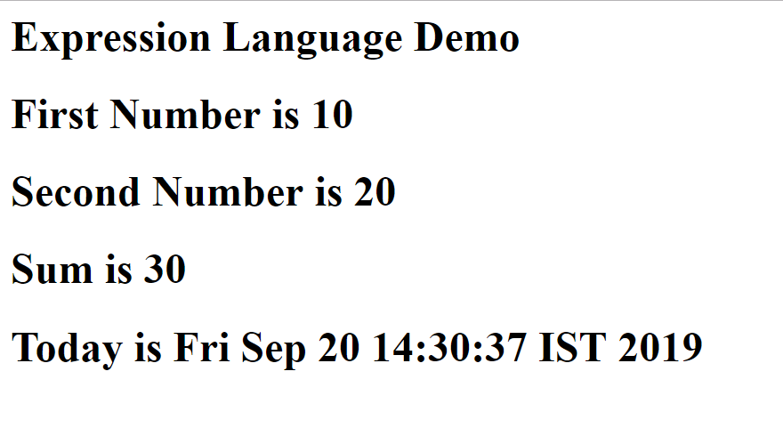

1. **Aim:** Create a JSP application to demonstrate the use of JSTL.

**Program Code:**

**index.html**

<!DOCTYPE html>

<!--

To change this license header, choose License Headers in Project Properties.

To change this template file, choose Tools | Templates

and open the template in the editor.

-->

<html>

<head>

<title>TODO supply a title</title>

<meta charset="UTF-8">

<meta name="viewport" content="width=device-width, initial-scale=1.0">

</head>

<body>

<a href='Table.jsp' >Click to open program</a>

</body>

</html>

**Table.jsp**

<%@taglib uri="http://java.sun.com/jsp/jstl/core" prefix="c" %>

<html>

<body>

<table border="1">

<th>Number </th>

<c:forEach var="i" begin="1" end="100" step="2" >

<tr><td> <c:out value="${i}" /> <br /> </td></tr>

</c:forEach>

</table>

</body>

</html>

**Output:**

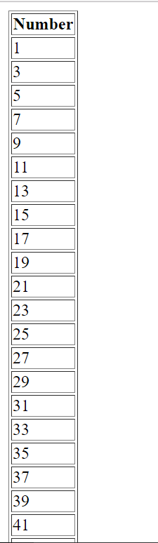

**Practical-6**

1. **Aim:** Create a Currency Converter application using EJB.

**Program Code:**

**index.html**

<html><head><title>Currency Converter</title></head>

<body>

<form action="CCServlet" >

Enter Amount <input type="text" name="amt"><br>

Select Conversion Type

<input type="radio" name="type" value="r2d" checked>Rupees to Dollar

<input type="radio" name="type" value="d2r" >Dollor to Rupees<br>

<input type="reset" ><input type="submit" value="CONVERT" >

</form>

</body>

</html>

**CCServlet.java**

package mypack;

import java.io.*;

import javax.servlet.*;

import javax.servlet.http.*;

import javax.ejb.EJB;

import mybeans.CCBean;

public class CCServlet extends HttpServlet {

@EJB CCBean obj;

public void doGet(HttpServletRequest request, HttpServletResponse response)

throws ServletException, IOException {

response.setContentType("text/html;charset=UTF-8");

PrintWriter out = response.getWriter();

double amt = Double.parseDouble(request.getParameter("amt"));

if(request.getParameter("type").equals("r2d"))

{

out.println("<h1>"+amt+ " Rupees = "+obj.r2Dollor(amt)+" Dollors</h1>");

}

if(request.getParameter("type").equals("d2r"))

{

out.println("<h1>"+amt+ " Dollors = "+obj.d2Rupees(amt)+" Rupees</h1>");

}

}}

**CCBean.java**

package mybeans;

import javax.ejb.Stateless;

@Stateless

public class CCBean {

public CCBean(){}

public double r2Dollor(double r){ return r/65.65; }

public double d2Rupees(double d){ return d*65.65; }

}

**Output:**

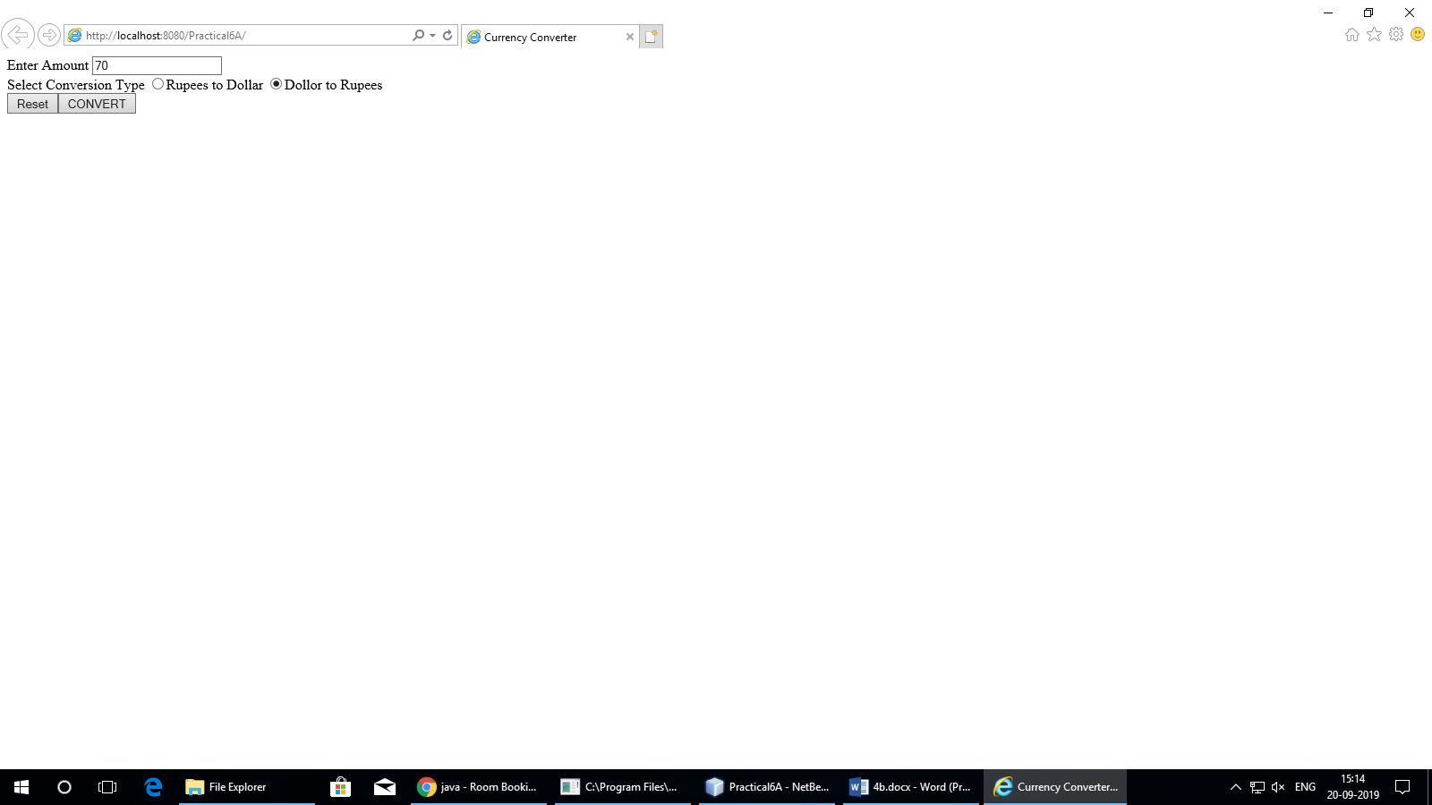

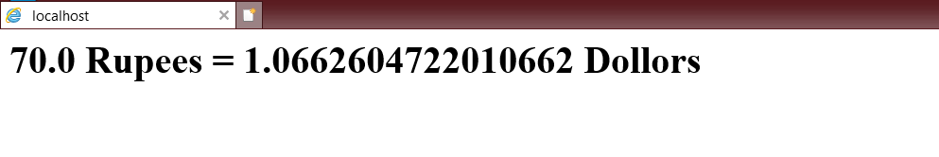

1. **Aim:** Develop a Simple Room Reservation System Application Using EJB.

**Program Code:**

**index.html**

<html><head><title>Room Reservation System</title></head>

<body>

<h1><a href="Book.html" >Click to Book a Room</a></h1>

<h1><a href="Cancle.html" >Click to Cancle a Room</a></h1>

</body>

</html>

**Book.html**

<form action="RBServlet" >

Select a room Type

<input type="radio" name="txtType" value="Delux">Delux

<input type="radio" name="txtType" value="Super Delux">Super Delux

<input type="radio" name="txtType" value="Suit">Suit<br>

Enter Your Name<input type="text" name="txtCust" ><br>

Enter Mobile No.<input type="text" name="txtMob" ><br>

<input type="reset" ><input type="submit" value="Book Room">

</form>

**RBServlet.java**

package mypack;

import java.io.*;

import javax.servlet.*;

import javax.servlet.http.*;

import javax.ejb.EJB;

import mybeans.RRBean;

public class RBServlet extends HttpServlet {

@EJB RRBean obj;

public void doGet(HttpServletRequest request, HttpServletResponse response)

throws ServletException, IOException{

PrintWriter out=response.getWriter();

String rt=request.getParameter("txtType");

String cn=request.getParameter("txtCust");

String cm=request.getParameter("txtMob");

String msg = obj.roomBook(rt, cn, cm);

out.println(msg);

}

}

**RRBean.java**

package mybeans;

import javax.ejb.Stateless;

import java.sql.*;

@Stateless

public class RRBean {

public RRBean(){}

public String roomBook(String rt, String cn, String cm){

String msg="";

try{

Class.forName("com.mysql.jdbc.Driver");

Connection con = DriverManager.getConnection("jdbc:mysql://localhost:3306/rrdb","root","root");

String query="select * from roombook where RoomType=? and status='Not Booked'";

PreparedStatement pst = con.prepareStatement(query);

pst.setString(1,rt);

ResultSet rs= pst.executeQuery();

if(rs.next()){

String rno=rs.getString(1);

PreparedStatement stm1 = con.prepareStatement("update roombook set cust=? where RoomId=? ");

PreparedStatement stm2 = con.prepareStatement("update roombook set mobile=? where RoomId=? ");

PreparedStatement stm3 = con.prepareStatement("update roombook set status=? where RoomId=? ");

stm1.setString(1,cn); stm1.setString(2,rno);

stm2.setString(1,cm); stm2.setString(2,rno);

stm3.setString(1, "Booked"); stm3.setString(2,rno);

stm1.executeUpdate();

stm2.executeUpdate();

stm3.executeUpdate();

msg = "Room "+rno+ " Booked <br> Charges = "+rs.getString(3);

}

else

{

msg = "Room "+rt+ " currently Not available";

}

}catch(Exception e){msg=""+e;}

return msg;

}

}

**Output:**

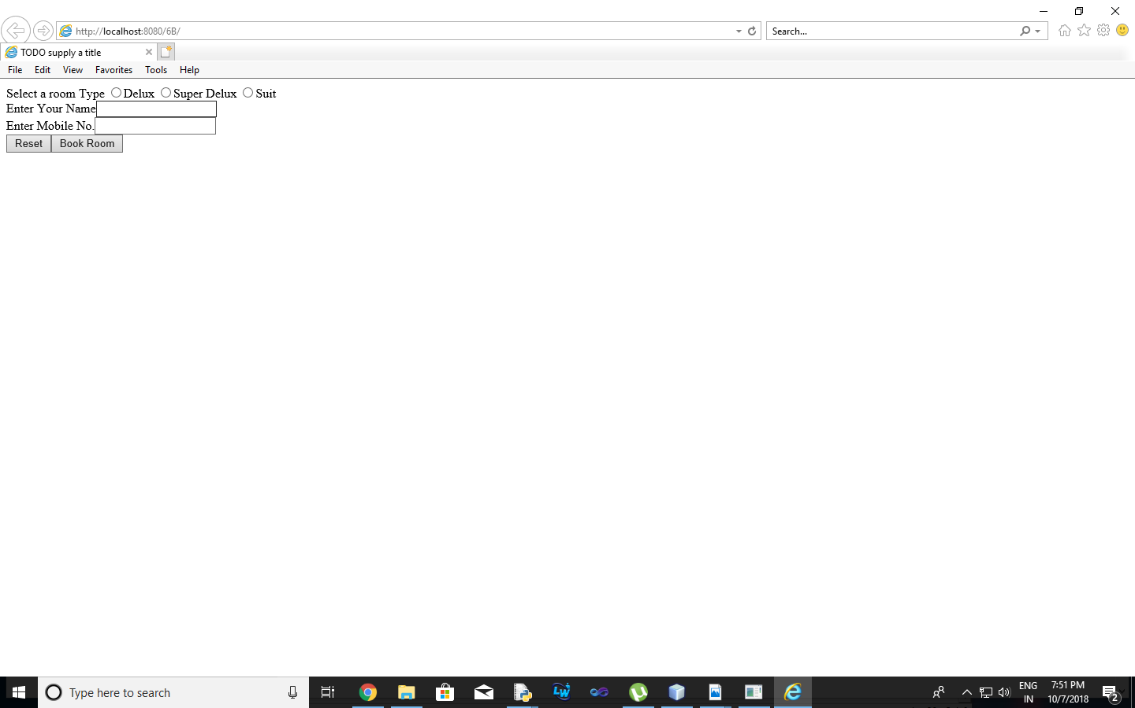

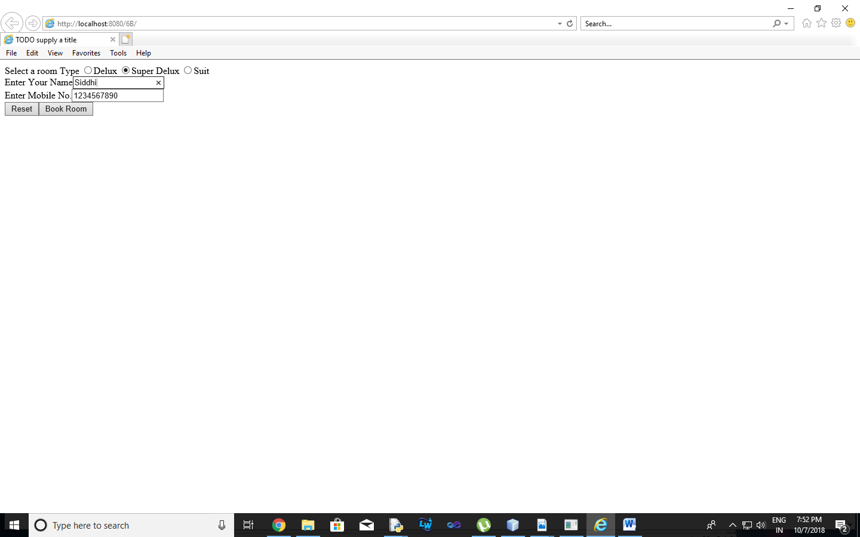

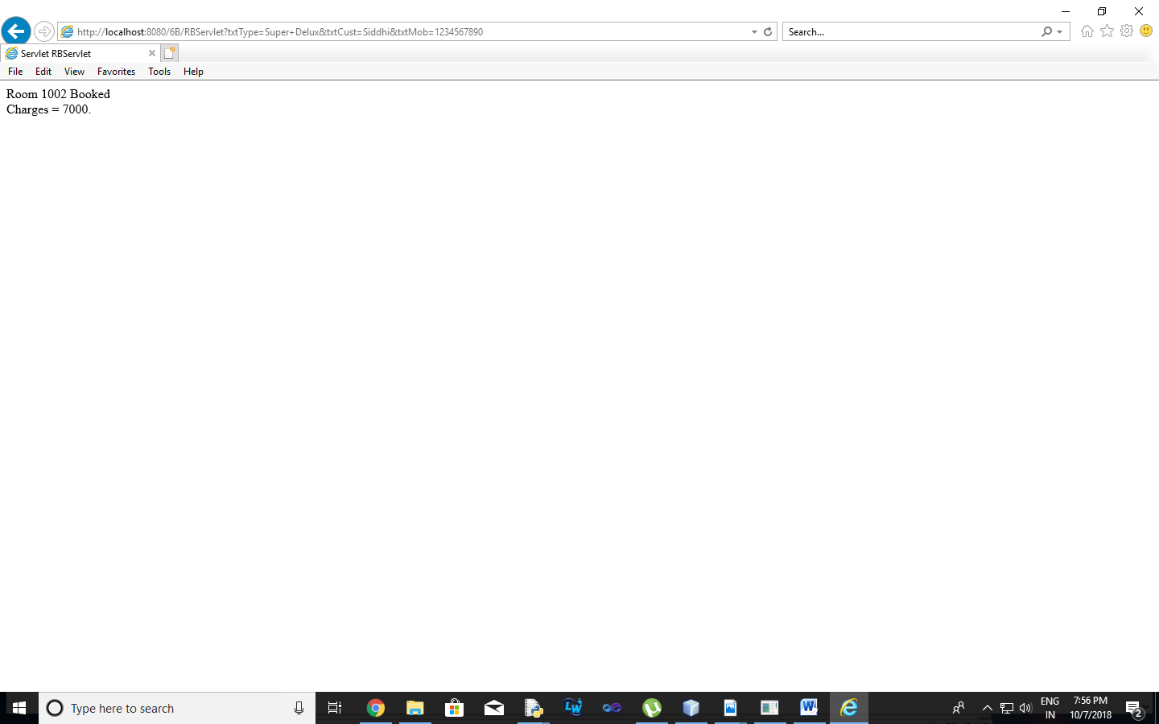

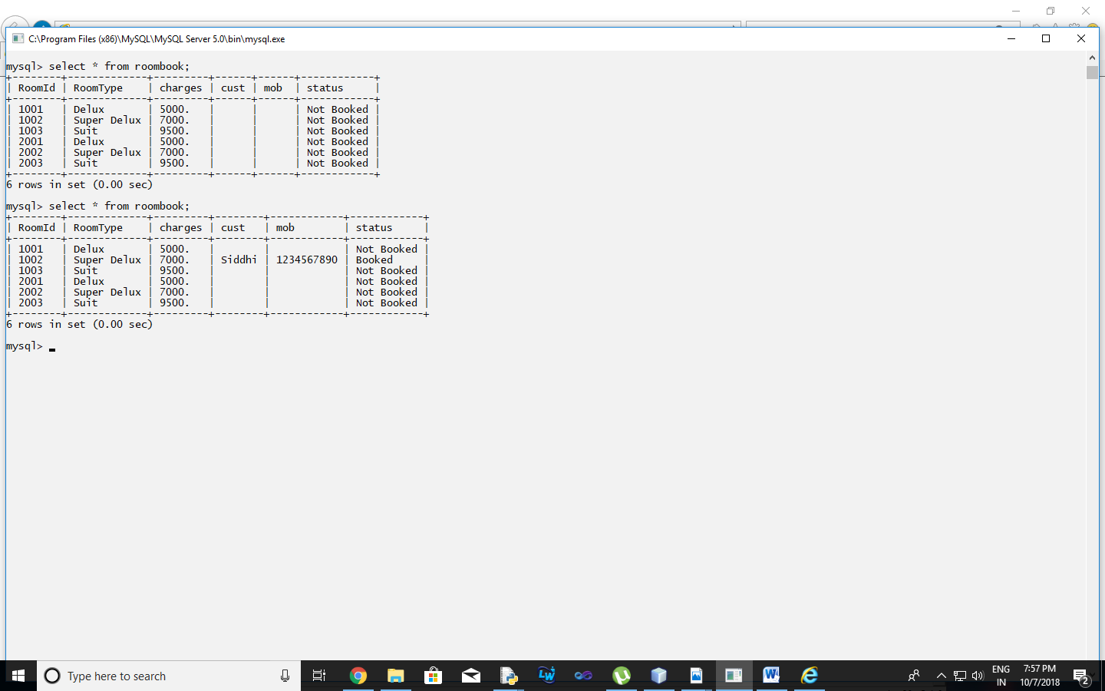

1. **Aim:** Develop simple shopping cart application using EJB [Stateful Session Bean].

**Program Code:**

**index.jsp**

<%@page import="java.util.Iterator, java.util.List, javax.naming.InitialContext, ejb.ShoppingCart"%>

<%@page contentType="text/html" pageEncoding="UTF-8"%>

<!DOCTYPE html>

<%!

private static ShoppingCart cart;

public void jspInit() {

try {

InitialContext ic = new InitialContext();

cart = (ShoppingCart) ic.lookup("java:global/ShoppingCart/ShoppingCart");

} catch (Exception ex) {

System.out.println("Could not create cart bean." + ex.getMessage());

}

}

%>

<%

if(request.getParameter("txtCustomerName") != null) {

cart.initialize(request.getParameter("txtCustomerName"));

} else {

cart.initialize("Guest");

}

if (request.getParameter("btnRmvBook") != null) {

String books[] = request.getParameterValues("chkBook");

if (books != null) {

for (int i=0; i<books.length; i++) {

cart.removeBook(books[i]);

}

}

}

if (request.getParameter("btnAddBook") != null) {

String books[] = request.getParameterValues("chkBook");

if (books != null) {

for (int i=0; i<books.length; i++) {

cart.addBook(books[i]);

}

}

}

%>

<html>

<head>

<meta http-equiv="Content-Type" content="text/html; charset=UTF-8">

<title>Shopping Cart</title>

</head>

<body style="background-color: pink;">

<h1 style="text-align: center;">Books For Sale</h1><br>

<form name="frmBooks" method="post">

<table style="background-color: pink; width: 100%; padding: 1px; border-spacing: 1px;">

<tr style="background-color: pink;">

<td style="width: 70%">

<table style="padding: 1px 1px 1px 1px; border-spacing: 1px; border: 2px solid maroon; width: 400px;">

<tr>

<td style="border: 2px solid maroon;">Customer</td>

<td style="border: 2px solid maroon;">

<input type="text" name="txtCustomerName" value=<%= request.getParameter("txtCustomerName")%> />

</td>

</tr>

<tr style="background-color: maroon;">

<th style="text-align: left; width: 340px; color: white; border: 2px solid maroon;" colspan="2">

<b>Book Titles</b>

</th>

</tr>

<tr>

<td style="border: 2px solid maroon;">

<input type="checkbox" name="chkBook" value="Struts 2.0 For Beginners">

</td>

<td style="width: 340px; border: 2px solid maroon;">Struts 2.0 For Beginners</td>

</tr>

<tr>

<td style="border: 2px solid maroon;">

<input type="checkbox" name="chkBook" value="Oracle 11g For Professionals">

</td>

<td style="width: 340px; border: 2px solid maroon;">Oracle 11g For Professionals</td>

</tr>

<tr>

<td style="border: 2px solid maroon;">

<input type="checkbox" name="chkBook" value="Hibernate 3 For Beginners">

</td>

<td style="width: 340px; border: 2px solid maroon;">Hibernate 3 For Beginners</td>

</tr>

<tr>

<td style="border: 2px solid maroon;">

<input type="checkbox" name="chkBook" value="Java Persistence API In EJB 3 For Beginners">

</td>

<td style="width: 340px; height: 24px; border: 2px solid maroon;">Java Persistence API In EJB 3 For Beginners</td>

</tr>

<tr>

<td colspan="4" style="border: 2px solid maroon;">

<table style="background-color: pink; text-align: center;">

<tr>

<td style="text-align: center;">

<input type='submit' value='Add To My Basket' name='btnAddBook'>

</td>

<td style="text-align: center;">

<input type='submit' value='Remove From My Basket' name='btnRmvBook'>

</td>

</tr>

</table>

</td>

</tr>

</table>

</td>

<td>

<table style="border: 1px solid blue; width: 300px; height: 180px; text-align: right;">

<tr>

<td style="text-align: center; background-color: lightblue; border: 1px solid blue; height: 20px;">Basket</td>

</tr>

<%

if(cart!=null){

List<String> bookList = cart.getContents();

Iterator iterator = bookList.iterator();

while (iterator.hasNext()) {

String title = (String) iterator.next();

%>

<tr>

<td style="text-align: left; background-color: lightblue; border: 1px solid blue;"><%= title %></td>

</tr>

<%

}

}

%>

</table>

</td>

</tr>

</table>

</form>

</body>

</html>

**ShoppingCart.java**

package ejb;

import java.sql.Connection;

import java.sql.DriverManager;

import java.sql.ResultSet;

import java.sql.SQLException;

import java.sql.Statement;

import java.util.ArrayList;

import java.util.List;

import javax.ejb.Remove;

import javax.ejb.Stateful;

@Stateful

public class ShoppingCart {

List<String> contents;

String customerName;

private Connection conn = null;

private ResultSet rs;

private Statement stmt = null;

private String query = null;

public void initialize(String person) {

if (person != null) {

customerName = person;

try {

Class.forName("com.mysql.jdbc.Driver").newInstance();

conn = DriverManager.getConnection("jdbc:mysql://localhost:3306/mysql", "root", "root");

} catch(ClassNotFoundException | IllegalAccessException | InstantiationException | SQLException e) {

System.err.println("Sorry failed to connect to the Database." + e.getMessage());

}

}

contents = new ArrayList<>();

}

public void addBook(String title) {

try {

stmt = conn.createStatement();

query = "INSERT INTO cart VALUES('" + customerName + "','" + title + "')";

stmt.executeUpdate(query);

} catch(SQLException e) {

System.err.println("Sorry failed to insert values from the database table. " + e.getMessage());

}

}

public void removeBook(String title) {

try {

stmt = conn.createStatement();

query = "DELETE FROM cart WHERE uname='" + customerName + "' AND itemname='" + title + "'";

stmt.executeUpdate(query);

} catch(SQLException e) {

System.err.println("Sorry failed to delete values from the database table. " + e.getMessage());

}

}

public List<String> getContents() {

try {

stmt = conn.createStatement();

query = "SELECT * FROM cart WHERE uname='" + customerName + "'";

rs = stmt.executeQuery(query);

while(rs.next()) {

contents.add(rs.getString("itemname"));

}

} catch(SQLException e) {

System.err.println("Sorry failed to select values from the database table. " + e.getMessage());

}

return contents;

}

@Remove()

public void remove() {

contents = null;

}

}

**Output:**

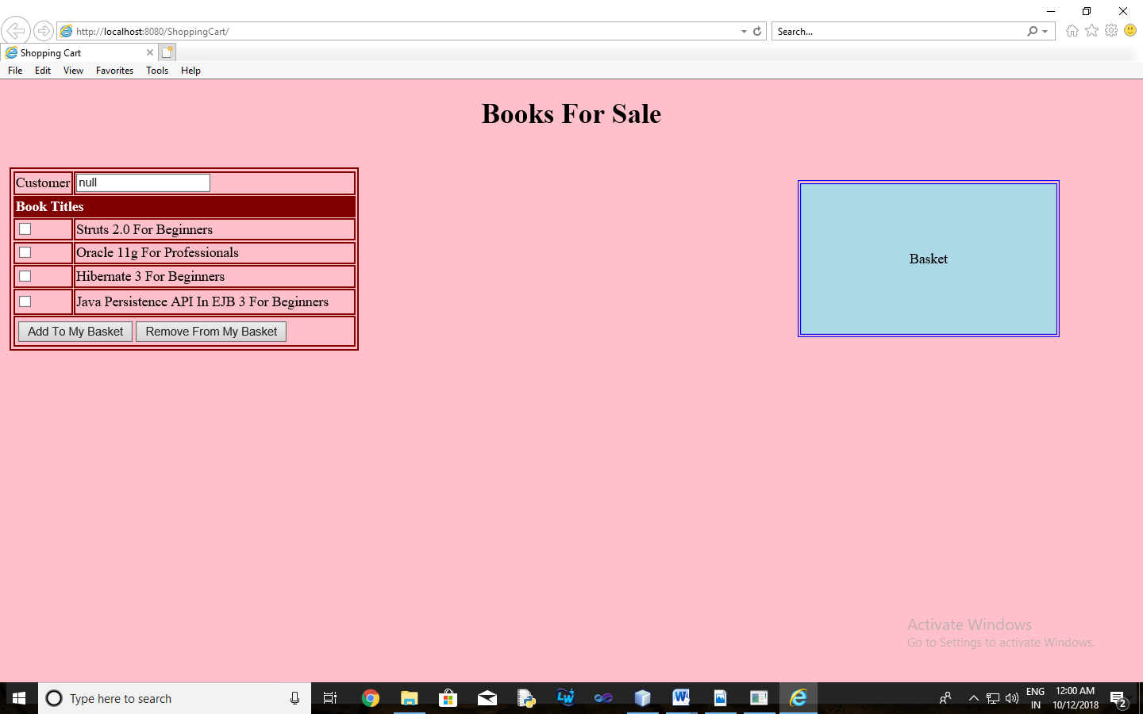

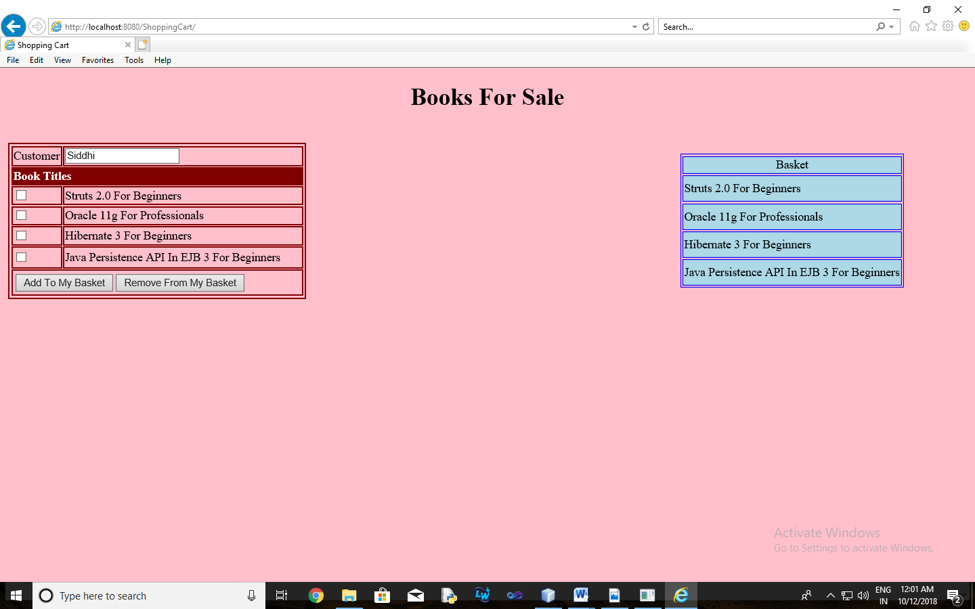

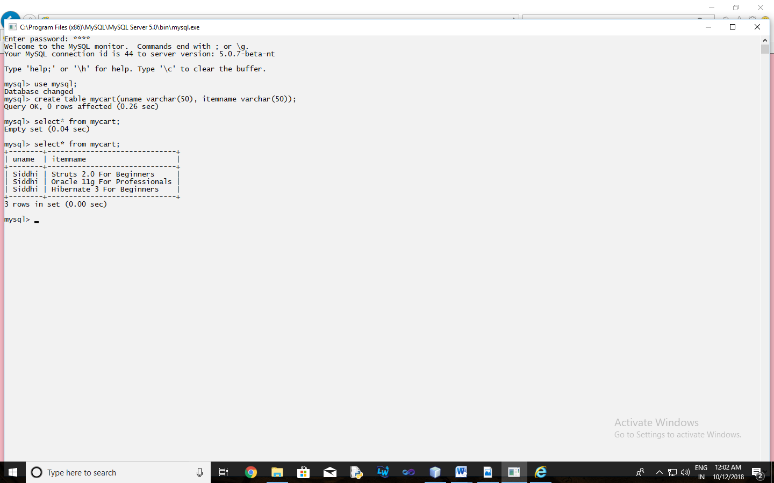

**Practical-7**

1. **Aim:** Develop simple EJB application to demonstrate Servlet Hit count using Singleton Session Beans.

**Program Code:**

**index.xhtml**

<?xml version='1.0' encoding='UTF-8' ?>

<!DOCTYPE html PUBLIC "-//W3C//DTD XHTML 1.0 Transitional//EN" "http://www.w3.org/TR/xhtml1/DTD/xhtml1-transitional.dtd">

<html xmlns="http://www.w3.org/1999/xhtml"

xmlns:h="http://xmlns.jcp.org/jsf/html">

<h:head>

<title>Page Hit Counter using Singleton EJB </title>

</h:head>

<h:body>

<h1>Welcome to Hit Count Page</h1>

Page was hit #{count.hitCount} times

</h:body>

</html>

**web.xml**

<?xml version="1.0" encoding="UTF-8"?>

<web-app version="3.1" xmlns="http://xmlns.jcp.org/xml/ns/javaee" xmlns:xsi="http://www.w3.org/2001/XMLSchema-instance" xsi:schemaLocation="http://xmlns.jcp.org/xml/ns/javaee http://xmlns.jcp.org/xml/ns/javaee/web-app_3_1.xsd">

<context-param>

<param-name>javax.faces.PROJECT_STAGE</param-name>

<param-value>Development</param-value>

</context-param>

<servlet>

<servlet-name>Faces Servlet</servlet-name>

<servlet-class>javax.faces.webapp.FacesServlet</servlet-class>

<load-on-startup>1</load-on-startup>

</servlet>

<servlet-mapping>

<servlet-name>Faces Servlet</servlet-name>

<url-pattern>/faces/*</url-pattern>

</servlet-mapping>

<session-config>

<session-timeout>

30

</session-timeout>

</session-config>

<welcome-file-list>

<welcome-file>faces/index.xhtml</welcome-file>

</welcome-file-list>

</web-app>

**Count.java**

package mypack;

import java.io.Serializable;

import javax.ejb.EJB;

import javax.enterprise.context.ConversationScoped;

import javax.inject.Named;

import counter.ejb.CounterBean;

@Named("count")

@ConversationScoped

public class Count implements Serializable {

@EJB

private CounterBean counterBean;

private int hitCount;

public Count() {

this.hitCount = 0;

}

public int getHitCount() {

hitCount = counterBean.getHits();

return hitCount;

}

public void setHitCount(int newHits) {

this.hitCount = newHits;

}

}

**CounterBean.java**

package counter.ejb;

import javax.ejb.Singleton;

@Singleton

public class CounterBean {

private int hits = 1;

// Increment and return the number of hits

public int getHits() {

return hits++;

}

}

**Output:**

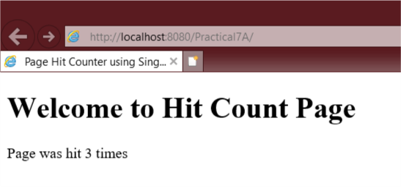

1. **Aim:** Develop simple visitor Statistics application using Message Driven Bean [Stateless Session Bean].

**Program Code:**

**index.jsp**

<%@page import="javax.jms.JMSException, javax.naming.InitialContext, javax.jms.TextMessage, javax.jms.MessageProducer, javax.jms.Session, javax.jms.Connection, javax.jms.Queue, javax.jms.ConnectionFactory" %>

<%@page contentType="text/html" pageEncoding="UTF-8"%>

<!DOCTYPE html>

<%!

private static ConnectionFactory connectionFactory;

private static Queue queue;

Connection connection = null;

Session mysession = null;

MessageProducer messageProducer = null;

TextMessage message = null;

%>

<html>

<head>

<meta http-equiv="Content-Type" content="text/html; charset=UTF-8">

<title>Welcome To Enterprise Java Home Page</title>

</head>

<body style="background-color: pink;">

<h1>Welcome To Enterprise Java Home Page</h1>

<%

try {

InitialContext ctx = new InitialContext();

queue = (Queue) ctx.lookup("jms/Queue");

connectionFactory = (ConnectionFactory) ctx.lookup("jms/QueueFactory");

connection = connectionFactory.createConnection();

mysession = connection.createSession(false, Session.AUTO_ACKNOWLEDGE);

messageProducer = mysession.createProducer(queue);

message = mysession.createTextMessage();

message.setText(request.getRemoteAddr());

messageProducer.send(message);

} catch (JMSException e) {

System.out.println("Exception occurred: " + e.toString());

}

%>

</body>

</html>

**newjsp.jsp**

<%--

Document : newjsp

Created on : Jun 20, 2019, 10:18:39 AM

Author : admin

--%>

<%@page contentType="text/html" pageEncoding="UTF-8"%>

<!DOCTYPE html>

<html>

<head>

<meta http-equiv="Content-Type" content="text/html; charset=UTF-8">

<title>JSP Page</title>

</head>

<body>

<h1>Hello World! Enterprise Java</h1>

<h1><%=new java.util.Date()%></h1>

<h1>3+4 is: <%=3+4%></h1>

</body>

</html>

**BasicMessageBean.java**

package ejb;

import javax.annotation.Resource;

import javax.ejb.ActivationConfigProperty;

import javax.ejb.EJB;

import javax.ejb.MessageDriven;

import javax.ejb.MessageDrivenContext;

import javax.jms.JMSException;

import javax.jms.Message;

import javax.jms.MessageListener;

import javax.jms.TextMessage;

@MessageDriven(activationConfig = {

@ActivationConfigProperty(propertyName = "destinationType", propertyValue = "javax.jms.Queue"),

@ActivationConfigProperty(propertyName = "destinationLookup", propertyValue = "jms/Queue")

})

public class BasicMessageBean implements MessageListener {

@EJB

VisitorStatBean vs;

@Resource

private MessageDrivenContext mdc;

public BasicMessageBean() {

}

@Override

public void onMessage(Message message) {

try {

if (message instanceof TextMessage) {

TextMessage msg = (TextMessage) message;

vs.addVisitor(msg.getText());

}

} catch (JMSException e) {

mdc.setRollbackOnly();

}

}

}

**VisitorStatBean.java**

package ejb;

import java.sql.Connection;

import java.sql.DriverManager;

import java.sql.ResultSet;

import java.sql.SQLException;

import java.sql.Statement;

import javax.annotation.PostConstruct;

import javax.annotation.PreDestroy;

import javax.ejb.Stateless;

@Stateless

public class VisitorStatBean {

private Connection conn = null;

private ResultSet rs;

private Statement stmt = null;

private String query = null;

@PostConstruct

public void connect() {

try {

Class.forName("com.mysql.jdbc.Driver").newInstance();

conn = DriverManager.getConnection("jdbc:mysql://localhost:3306/visitorstat", "root", "root");

System.out.println("Database connection established successfully.");

} catch(ClassNotFoundException | InstantiationException | IllegalAccessException | SQLException e) {

System.err.println("Sorry failed to connect to the Database.");

}

}

@PreDestroy

public void disconnect() {

try {

conn.close();

System.out.println("Database connection closed successfully.");

} catch(SQLException e) {

System.err.println("Cannot close the database connection: " + e.getMessage());

}

}

public void addVisitor(String host) {

try {

stmt = conn.createStatement();

query = "INSERT INTO UserStat (hostname, visits) VALUES('" + host + "','1')";

stmt.executeUpdate(query);

} catch(SQLException e) {

try {

stmt = conn.createStatement();

query = "UPDATE UserStat SET visits = visits + 1 WHERE hostname = '" + host + "'";

stmt.executeUpdate(query);

} catch(SQLException ex) {

System.err.println("Cannot update: " + ex.getMessage());

}

}

}

}

**Output:**

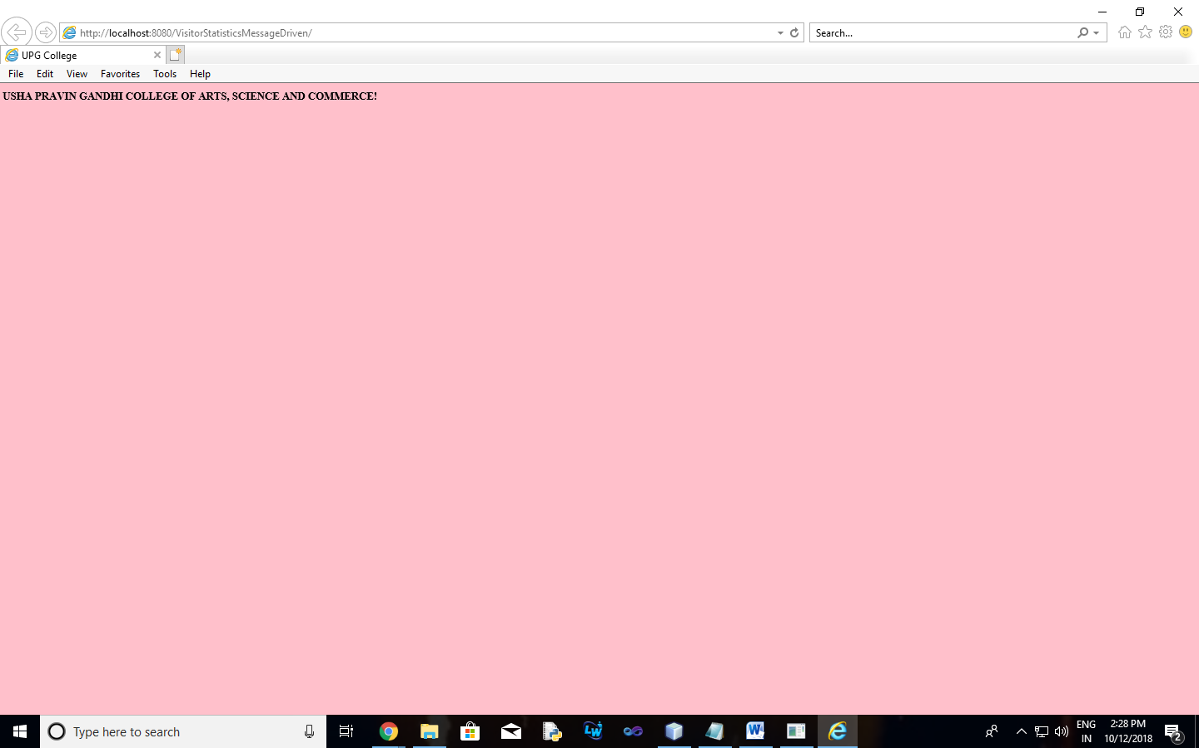

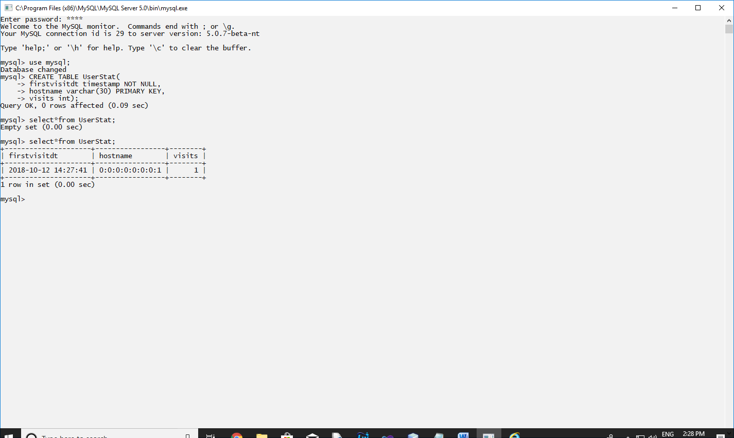

1. **Aim:** Develop simple Marks Entry Application to demonstrate accessing Database using EJB.

**Program Code:**

**index.html**

Top of Form

<html>

<head>

<title>TODO supply a title</title>

<meta charset="UTF-8">

<meta name="viewport" content="width=device-width, initial-scale=1.0">

</head>

<body>

<form action="RBServlet" >

Enter Student Name<input type="text" name="txtCust" ><br>

Enter Subject<input type="text" name="sub"><br>

Enter Marks<input type="text" name="txtMob" ><br>

<input type="reset" value="RE-ENTER"><input type="submit" value="SUBMIT">

</form>

</body>

</html>

**RBServlet.java**

package mypack;

import java.io.IOException;

import java.io.PrintWriter;

import javax.ejb.EJB;

import javax.servlet.ServletException;

import javax.servlet.http.HttpServlet;

import javax.servlet.http.HttpServletRequest;

import javax.servlet.http.HttpServletResponse;

public class RBServlet extends HttpServlet {

@EJB RRBean obj;

protected void processRequest(HttpServletRequest request, HttpServletResponse response)

throws ServletException, IOException {

response.setContentType("text/html;charset=UTF-8");

{

try (PrintWriter out = response.getWriter()) {

String s=request.getParameter("sub");

String n=request.getParameter("txtCust");

String m=request.getParameter("txtMob");

String msg = obj.markenter(n, s, m);

response.setContentType("text/html;charset=UTF-8");

out.println(msg);

out.println("<!DOCTYPE html>");

out.println("<html>");

out.println("<head>");

out.println("<title>Servlet RBServlet</title>");

out.println("</head>");

out.println("<body>");

out.println("<h1>Records Inserted Successfully</h1>");

out.println("</body>");

out.println("</html>");

}

}

}

**RRBean.java**

package mypack;

import javax.ejb.Stateless;

import java.sql.*;

@Stateless

public class RRBean {

public RRBean(){}

public String markenter(String n, String s,String m){

String msg;

try{

Class.forName("com.mysql.jdbc.Driver");

Connection con = DriverManager.getConnection("jdbc:mysql://localhost:3306/rrdb","root","root123");

String query="insert into student1 values(?,?,?)";

PreparedStatement pst = con.prepareStatement(query);

pst.setString(1,n);

pst.setString(2,s);

pst.setString(3,m);

pst.executeUpdate();

msg="Marks entered";

}

catch(Exception e){msg=""+e;}

return msg;

}

}

